ADP GlobalView®

Configuration Handbook: Vietnam

Commercial in Confidence

|  |  |
| --- | --- |
| Author | Product Consultant |
| Document Reference | GV00007765 |
| Date | 2017/09/26 |
| Version | 2.0 |

##### Copyright and Confidentiality

Copyright © 2012, 2016 ADP, LLC. ADP Proprietary and Confidential - All Rights Reserved. For Internal Use Only. These materials may not be reproduced in any format without the express written permission of ADP, LLC. This document must be kept strictly confidential at all times. It must not be disclosed to any person without the prior written consent of ADP, LLC.

ADP provides this publication "as is" without warranty of any kind, either express or implied, including, but not limited to, the implied warranties of merchantability or fitness for a particular purpose. ADP is not responsible for any technical inaccuracies or typographical errors which may be contained in this publication. Changes are periodically made to the information herein, and such changes will be incorporated in new editions of this publication. ADP may make improvements and/or changes in the product and/or the programs described in this publication at any time without notice.

The ADP® logo and ADP® letters are registered trademarks of ADP, LLC. GlobalView® is a registered trademark of ADP, LLC. iLearn@ADP® is a registered trademark of ADP, LLC. In the Business of Your Success(SM) is a service mark of ADP, LLC.

**Third-Party Trademarks**

Adobe® is a registered trademark and Acrobat(TM) is a trademark of Adobe Systems Incorporated.

Microsoft®, Windows®, Internet Explorer®, Word®, and Excel® are registered trademarks of Microsoft Corporation.

SAP® and SAP® R/3® are registered trademarks of SAP AG in Germany and in several other countries.

All other trademarks and service marks are the property of their respective owners.

##### Authorizations and Amendments History

| Version | Authored | Approved | CRM Ticket | Next Review Date |
| --- | --- | --- | --- | --- |
| 1.0 | 18 May 2012  Elisa Stewart | 18 May 2012 Teresa Su |  |  |
| 1.1 Updated to current ADP branding. | 2016/03/15 Diana Hope GVAA0188 | 2016/03/15  Diana Hope GVAA0188 | 2003431519 | As required |
| 2.0 | 2017/09/26  Teresa Su  GVAA0127 | 2017/09/26  Teresa Su  GVAA0127 |  |  |

##### Table of Contents

Purpose of Document 9

Golden Rules 10

Country Parameters 10

Legislative Overview 11

Social Insurance (SI) 11

Tax 11

Vietnam Reporting 12

Monthly Reporting 12

Annual Reporting 13

Company Code 14

IMG Path & Table: Define Company 14

IMG Path & Table: Define, Copy, Delete, Check Company Code 15

IMG Path & Table: Assign Company Code to Company 16

IMG Path & Table: Cross System Company Codes 17

IMG Path & Table: Enter Global Parameters 17

IMG Path & Table: Define Document Number Ranges 18

IMG Path & Table: Assign Company Code to Controlling Area 18

IMG Path & Table: Assign Company Code to Controlling Area 18

IMG Path & Table: Activate Cost Center Accounting in Controlling Area 19

IMG Path & Table: Define Document Number Ranges 19

IMG Path & Table: Set up Paying Company Codes for Payment Transactions 20

Enterprise Structure 21

IMG Path & Table: Personnel Areas 21

IMG Path & Table: Personnel Subareas 21

IMG Path & Table: Employee Groups 22

IMG Path & Table: Employee SubGroups 23

IMG Path & Table: Assignment of Personnel Area to Company Code 24

IMG Path & Table: Assignment of Employee Subgroup to Employee Group 24

Pay Frequency 26

IMG Path & Table: Define Period Modifiers 26

IMG Path & Table: Define Date Modifiers 26

IMG Path & Table: Check Payroll Accounting Area 27

Generate Payroll Periods 27

Generate Cumulation Calendar 27

Date Type 29

Payments 30

Total Gross Amount – Cumulation 01 30

CSI Appl. Earning – Cumulation 02 30

VSI Appl. Earning – Cumulation 03 30

UI Appl. Earning – Cumulation 04 30

HI Appl. Earning – Cumulation 05 30

Taxable Income – Cumulation 06 31

Contract Salary – Cumulation 71 31

House Rent taxable portion – Cumulation 72 33

Meal Allowance – Cumulation 76 33

Trade Union – Cumulation 75 34

Overtime Wagetypes – Processing class 64 36

AWS wagetypes – Processing class 67 36

Minimum Pay – Processing class 69 36

Severance Pay – Processing class 70 38

Other Taxable Implications – Processing class 71 38

Absence Categories for reporting – Processing class 80 40

Year of Service processing – Processing class 83 40

Window on Payslip 40

Pay Scale Structure 41

IMG Path & Table: Define EE Subgroup Grouping for PCR and Collective Agreement Provision (CAP). 41

IMG Path & Table: Payscale Conversion for Basic Pay 42

IMG Path & Table: Check Pay Scale Type 43

IMG Path & Table: Check Pay Scale Area 44

IMG Path & Table: Check Assignment of Payscale Structure to Enterprise Structure 44

IMG Path & Table: Define Default for Pay Scale Data 45

IMG Path & Table: Set up payroll period for Collective Agreement Provision 45

IMG Path & Table: Define Hourly Rates with Several Decimal Places 46

IMG Path & Table: Revise Pay Scale Groups and Levels 47

IMG Path & Table: Specify Working Hours fixed by Collective Agreement 47

IMG Path & Table: Revise Default Wage Types 48

IMG Path & Table: Enterprise Structure for Wage Type Model 49

IMG Path & Table: Define Valuation of Base Wage Types 49

Rates of Pay 51

Pro-Rata and Factoring 52

Deductions 53

Total Deductions 53

VSI Appl. Earning 53

UI Appl. Earning 53

HI Appl. Earning 53

Taxable Income 53

Double Tax Amount 54

SI Employee Payment 54

Annual Payment taxable 54

Window on Payslip 54

Holiday Calendar 55

IMG Path & Table: Define Public Holiday Classes 55

Work Patterns 56

IMG Path & Table: Define Break Schedules 56

IMG Path & Table: Define Rules for Variants 57

IMG Path & Table: Define Daily Work Schedules 57

IMG Path & Table: Define Period Work Schedules 58

IMG Path & Table: Set Work Schedule Rules and Work Schedules 59

IMG Path & Table: Generate Work Schedules in Batch 59

Absences 60

IMG Path & Table: Define Absence Types 60

IMG Path & Table: Define Counting Classes for the Period work Schedule 61

IMG Path & Table: Define Counting Rules 62

IMG Path & Table: Define Deduction Rules 62

IMG Path & Table: Assign Counting Rules to Absence Types 63

IMG Path & Table: Describe Absence Valuation Rules 64

IMG Path & Table: Group Absences for Absence Valuation 66

IMG Path & Table: Define Grouping for absence Valuation 67

IMG Path & Table: Create Counting Classes for Absence Valuation 68

IMG Path & Table: Valuate Absences using constants values or Averages 70

IMG Path & Table: VN: Absence report categories 71

IMG Path & Table: VN: Assign SI Absence Report Category to Absence 72

C70A reporting 74

Absence Quotas 84

IMG Path & Table: Define Absence Quota Types 84

IMG Path & Table: Permit Generation of Quotas in Time Evaluation 85

IMG Path & Table: Specify Rule Groups for Quota Type Selection 85

IMG Path & Table: Set Base Entitlements 86

IMG Path & Table: Determine Validity and Deduction Periods 87

IMG Path & Table: Determine Rules for Reducing Quota Entitlements 89

IMG Path & Table: Determine Rules for Rounding Quota Entitlements 89

IMG Path & Table: Determine Generation Rules for Quota Selection 90

Social Insurance (SI) 92

IMG Feature: Check default values for Compulsory Social Insurance 92

IMG Feature: Check default values for Voluntary Social Insurance 92

IMG Feature: Check default values for Unemployment Insurance 93

IMG Feature: Check default values for Health Insurance 93

IMG Path & Table: Define Province Codes 94

IMG Path & Table: Define Hospital Codes 97

IMG Path & Table: Define Social Insurance Types 97

IMG Path & Table: Define Social Insurance Funds 98

IMG Path & Table: Define Social Insurance Schemes 99

IMG Path & Table: Define Social Insurance Categories 99

IMG Path & Table: Define Social Insurance Contributions 99

IMG Path & Table: Define Social Insurance ER/EE Splits 100

SI calculation amendment on employees less than 14 working days 101

Tax 104

IMG Path & Feature: Default values – Tax Infotype 104

IMG Path & Table: Nature of Person 104

IMG Path & Table: Nationality 105

IMG Path & Table: Employment Category 105

IMG Path & Table: Tax Offices / Regions 106

IMG Path & Table: Tax Exempt Reasons 106

IMG Path & Table: Tax Rates 106

IMG Path & Table: Tax Deductions 108

IMG Table & Feature: Tax Finalisation 108

Severance Pay 110

*IMG Path & Feature: Severance Pay Date Type* 110

Gross up 111

*Wage types, Table & Schema: Severance Pay Date Type* 111

Reporting 127

IMG Table: Tax Deductions 127

Banking 143

IMG Path & Table: Set up House Banks 143

IMG Path & Table: Define Sending Banks 143

IMG Path & Table: Check Text Keys for Payment Transactions 144

Table & Feature: Identify Ordering party name 144

General Ledger 145

IMG Path & Table: Define Employee Grouping Account Determination 145

IMG Path & Table: Define Symbolic Accounts 146

IMG Path & Table: Define Symbolic Accounts 148

IMG Path & Table: Assigning Accounts 149

Schema and Rule Information 150

Standard SAP Schema 150

Standard ADP Schema 150

Standard ADP Rules Naming Convention - Vietnam 150

Country Specific Rules 150

Client Specific Rules 150

Schema: SI calculation amendment on employees less than 14 working days 151

Standard Feature 154

Feature -VNGL 154

Feature –VNFP 154

Feature –VNSC 154

# Purpose of Document

The purpose of this document is to detail the steps taken by a configurer to successfully implement the Vietnam Configuration.

In addition to this, the document will attempt to provide background information for the configurer to gain sufficient knowledge to understand the country that is being configured, including sample calculations and descriptions of country specific functions.

# Golden Rules

The Golden Rules describe the principles that define GlobalView. Please see the attached PDF which lists these principles.



# Country Parameters

|  |  |
| --- | --- |
| Parameter | Value |
| Country Code | 1 |
| Country Number | 98 |
| Currency | VND |
| ISO Country Code | VN |

# Legislative Overview

Vietnam has the following legislative components that are handled through the Vietnam Payroll System.

* Social Insurance (SI)
* Tax

## Social Insurance (SI)

**Website**

Social Insurance Office <http://www.baohiemxahoi.gov.vn/>

## Tax

**Website**

General Department of Taxation <http://www.gdt.gov.vn/wps/portal>

Please note: CRM document GV00004223 has more useful websites related to Vietnam.

Please also see Legislative Manager page for Vietnam: <https://gckb.adp.com/Vietnam>

# Vietnam Reporting

Please also see Vietnam Reports Mapping Document – GV00007895

## Monthly Reporting

| Period Reports | | |
| --- | --- | --- |
| 02/KK-TNCN  *(without Barcode, information purpose only)* | /EPIUSE/HVNCTF02 | Declaration form of deduction PIT for organization, personal that pay all income by salary |
| 07/KK-TNCN  *(without Barcode, information purpose only)* | /EPIUSE/HVNCTF07 | Declaration PIT for resident have income from salaries and wages and non-resident have income from salaries and wages or business and declare and pay directly to Tax Dept. |
| A01-TS | /EPIUSE/HVNCSIA01TS | List of new participant report to the SI Dept |
| A01a-TS | /EPIUSE/HVNCSIA01A | Declaration of new participant of Social insurance, Health insurance and Unemployment insurance |
| D02-TS | /EPIUSE/HVNCSID02_11 | List of changes report to the SI Dept 1111 |
| D02-TS 1018 | /EPIUSE/HVNCSD02_18 | List of changes report to the SI Dept 1018 |
| D03-TS | /EPIUSE/HVNCSID03 | HI Dependent Movement List |
| D03-TS 1018 | /EPIUSE/HVNCSD03_18 | HI Dependent Movement List 1018 |
| C70a-HCM | /EPIUSE/HVNCSI70A_H | HCM Payment list Sickness, Maternity, Convlescence |
| Vietnam SI Filling | /EPIUSE/HVNCSIEFI | Vietnam SI Filling Upload Data |
| Trade & Industry HCM | /EPIUSE/HVNAIHCM | Staff changes report to Trade and Industy Dept HCM |
| Trade & Industry HaNoi | /EPIUSE/HVNTAIHN | Trade & Industry – Ha Noi |

## Annual Reporting

|  |  |  |
| --- | --- | --- |
| 05-1-BK-TNCN  *(without Barcode, information purpose only)* | /EPIUSE/HVNCTF05A | Taxable Income on employment (resident with contract) |
| 05-2-BK-TNCN  *(without Barcode, information purpose only)* | /EPIUSE/HVNCTF05B | Taxable Income and withheld on (w/o contract) |
| 05-3-BK-TNCN  *(without Barcode, information purpose only)* | /EPIUSE/HVNCTF05C | Declaration of information dependent deduction |
| 05-QTT-TNCN  *(without Barcode, information purpose only)* | /EPIUSE/HVNCTF05 | Declaration of Tax Finalization - Annual |
| 09/KK-TNCN  *(without Barcode, information purpose only)* | /EPIUSE/HVNCTF09 | PIT Finalization form of individuals have income from salaries, wages and business |
| 09A/PL-TNCN  *(without Barcode, information purpose only)* | /EPIUSE/HVNCTF09A | Appendix of income from salaries, wages to be attached in 09/KK-TNCN |
| 20-TXN-TNXN | /EPIUSE/HVNCTF20TXN | Yearly income confirmation |

# Company Code

The Company code is as per SAP standard. There is no additional information required in terms of specific address formats for showing on the legislative reports.

The following tables must be configured for setting up the company code:

## IMG Path & Table: Define Company

Enterprise Structure 🡪 Definition 🡪 Financial Accounting 🡪 Define Company

Table: V_T880

| Co. | Name of the company | Ctr | Name of company 2 | Language | Street | P.O.Box | Zip | City | Curr. |
| --- | --- | --- | --- | --- | --- | --- | --- | --- | --- |
| VN10 | Vietnam Company 1(VN) | VN | Vietnam Company 1(VN) | EN |  |  |  | Ho Chi Minh City | VND |
| VN20 | Vietnam Company 2(VN) | VN | Vietnam Company 1(VN) | EN |  |  |  | Hanoi | VND |

In this step you can create companies. A company is an organizational unit in Accounting which represents a business organization according to the requirements of commercial law in a particular country.

You store basic data for each company in company definition. You only specify particular functions when you customize in Financial Accounting. Company G0000 is preset in all foreign key tables.

In the SAP system, consolidation functions in financial accounting are based on companies. A company can comprise one or more company codes.

When you create a company you should bear in mind the following points relating to group accounting:

* If your organization uses several **clients**, the companies which only appear as group-internal business partners, and are not operational in each system, must be maintained in each client. This is a precondition for the account assignment of a group-internal trading partner.
* Companies must be catalogued in a list of company IDs which is consistent across the group. The parent company usually provides this list of company IDs.
* It is also acceptable to designate legally dependent branches 'companies' and join them together as a legal unit by

## IMG Path & Table: Define, Copy, Delete, Check Company Code

Enterprise Structure 🡪 Definition 🡪 Financial Accounting 🡪 Define, Copy, Delete, Check Company Code

Table: V_T001

| CoCd | Company name | City | Cty | Curr. | Language | Address |
| --- | --- | --- | --- | --- | --- | --- |
| VN10 | Vietnam Company 1(VN) | Ho Chi Minh City | VN | VND | EN |  |
| VN10 | Vietnam Company 2(VN) | Hanoi | VN | VND | EN |  |

In this activity you create your company codes. The company code is an organizational unit used in accounting. It is used to structure the business organization from a financial accounting perspective.

We recommend that you copy a company code from an existing company code. This has the advantage that you also copy the existing company code-specific parameters. If necessary, you can then change certain data in the relevant application. This is much less time-consuming than creating a new company code. See "Recommendations" for more details about copying a company code.

If you do not wish to copy an existing company code, you can create a new company code and make all the settings yourself. You define your company codes by specifying the following information:

**Company code key**

You can select a four-character alpha-numeric key as the company code key. This key identifies the company code and must be entered when posting business transactions or creating company code-specific master data, for example.

**Company code name**

The name of the company (legal name).

**Address data**

The address data is necessary for correspondence and is printed on reports, such as the advance return for tax on sales/purchases.

**Country currency**

Your accounts must be managed in the national currency. This currency is also known as the local currency or the company code currency. Amounts that are posted in foreign currency are translated into local currency.

**Country key**

The country key specifies which country is to be seen as the home country; all other countries are interpreted as "abroad". This is significant for business and payment transactions because different forms are used for foreign payment transactions. This setting also enables you to use different address formatting for foreign correspondence.

**Language key**

The system uses the language key to determine text automatically in the language of the relevant country. This is necessary when creating checks, for example.

You do not specify the functional characteristic of the company code until configuring the relevant application.

You can set up several company codes per client to manage the accounts of independent organizations simultaneously.

At least one company code must be set up in each client.

To take full advantage of SAP system integration, you must link company codes to the organizational units of other applications. If, for example, you specify a CO account assignment (for example, cost center or internal order) when entering a document in FI, then the system must determine a controlling area to transfer this data to CO.

You must specify how the system is to determine the appropriate controlling area.

The system derives the controlling area from the company code if you assign it directly to a company code. You can also assign several company codes to one controlling area.

## IMG Path & Table: Assign Company Code to Company

Enterprise Structure 🡪 Assignment 🡪 Financial Accounting 🡪 Assign Company Code to Company

Table: V_001_Y

| CoCd | Company name | City | Co. |
| --- | --- | --- | --- |
| VN10 | Vietnam Company 1(VN) | Ho Chi Minh City | VN10 |
| VN20 | Vietnam Company 2(VN) | Hanoi | VN20 |

In this step you assign the company codes which you want to include in the group accounting to a company.

## IMG Path & Table: Cross System Company Codes

Basis Components 🡪 Application Link Enabling 🡪 Cross Application Settings 🡪 Global Organizational Units 🡪 Cross System Company Codes

Table: V_T001O

| XSCC |
| --- |
| VN10 |
| VN20 |

Cross-system company codes are used in the distribution in financial accounting. There is exactly one central system for each cross-system company code in the distributed environment. One company code has to be assigned to this cross-system company code on each system involved in the distribution.

When sending an IDoc with company code-dependent data, the company code is replaced with the cross-system company code in all company code fields. When receiving this kind of IDoc the reverse conversion takes place on the target system.

In this section you maintain the cross-system company codes and allocate them to the local company codes.

## IMG Path & Table: Enter Global Parameters

Financial Accounting 🡪 Company Code 🡪 Enter Global Parameters

Table: V_001_B

| CoCd | Company name | Cty | Curr. | Language | ChAc | Description | Var. | Max.ex.dev | FV | Address | XSCC | ChA2 | FStV | Var. |
| --- | --- | --- | --- | --- | --- | --- | --- | --- | --- | --- | --- | --- | --- | --- |
| VN10 | Vietnam Company 1(VN) | VN | VND | EN | INT | Sample chart of accounts | 2 | 10 | K4 |  | VN10 | INT | 0001 | 0001 |
| VN20 | Vietnam Company 1(VN) | VN | VND | EN | INT | Sample chart of accounts | 2 | 10 | K4 |  | VN20 | INT | 0001 | 0001 |

In this activity, you can make various global specifications for the company code. In addition, you can look at the most important specifications of the company code at any time in the overview. This includes, among other things, the chart of accounts and the fiscal year variant.

## IMG Path & Table: Define Document Number Ranges

Financial Accounting 🡪 Financial Accounting Global Settings 🡪 Document 🡪 Document Number Ranges 🡪 Define Document number ranges.

Transaction: FBN1

You can assign number range intervals to accounting documents in this section.

## IMG Path & Table: Assign Company Code to Controlling Area

Enterprise Structure 🡪 Assignment 🡪 Controlling 🡪 Assign Company Code to Controlling Area

Table: V_TKA01_GD

| COAr | Name | Curr. | ChAc | FV | C | StdHier | Var.CCCrcy | CC |
| --- | --- | --- | --- | --- | --- | --- | --- | --- |
| ADP | ADP Controlling Area | USD | INT | K4 | 2 | 0001 | X | 20 |

This step you assign the company codes for which you want to carry out common cost controlling to a controlling area.

## IMG Path & Table: Assign Company Code to Controlling Area

Enterprise Structure 🡪 Assignment 🡪 Controlling 🡪 Assign Company Code to Controlling Area

Table: V_TKA02

| CoCd | Company name | COAr | Name |
| --- | --- | --- | --- |
| VN10 | Vietnam Company 1(VN) | ADP | ADP Controlling Area |
| VN20 | Vietnam Company 2(VN) | ADP | ADP Controlling Area |

## IMG Path & Table: Activate Cost Center Accounting in Controlling Area

Controlling 🡪 Cost Center Accounting 🡪 Activate Cost Center Accounting in Controlling Area

Table: V_TKA00

| COAr | Year | Name | CC | OR | PA | PJ | Vr | Commt | CO | C | CV | PC | SO | Commt | BP | AA:AT | R |
| --- | --- | --- | --- | --- | --- | --- | --- | --- | --- | --- | --- | --- | --- | --- | --- | --- | --- |
| ADP | 2001 | ADP Controlling Area | 1 |  |  |  |  |  |  | X |  |  |  |  |  |  |  |

This IMG activity you use the controlling area control indicators to activate Cost Center Accounting (CO-CCA).

You use control indicators to activate or deactivate certain cost accounting functions by fiscal year.

The control indicators are valid as of the selected fiscal year, up to the fiscal year in which you maintain new indicators.

## IMG Path & Table: Define Document Number Ranges

Controlling 🡪 General Controlling🡪 Organization 🡪 Maintain Number Ranges for Controlling Documents

Transaction: KANK

In this IMG activity you create number ranges for business transactions in Controlling or change existing settings.

For every posting in CO the R/3 System generates a numbered document. The document numbers are unique to each controlling area, since each number is assigned only once.

In CO, there are no legal requirements for a continuous assignment of document numbers. To improve performance, after each restart of an application server, a maximum of 100 document numbers for each number range are not assigned.

Every transaction that you carry out on the controlling area level has to be assigned to a number range group.

A number range group, in turn, includes two document number intervals:

* An internal interval for all documents to which the user did not explicitly assign a document number;
* An external interval for all documents where the document numbers were assigned by the user, or which are brought into the R/3 System from a non-SAP system (for example, through **batch input**) and the original document numbers are to be retained.

If no external document number is given during posting, the R/3 System uses the next open number from the internal number interval of the transaction it belongs to.

## IMG Path & Table: Set up Paying Company Codes for Payment Transactions

Financial Accounting 🡪 Accounts Receivable and Accounts Payable 🡪 Business Transactions 🡪 Incoming Payments 🡪 Automatic Incoming Payments 🡪 Payment Method/Bank Selection for Payment Program 🡪 Set up Paying Company Codes for Payment Transactions

Table: V_T042B

| CoCd | Company name | Form for the payment advice |
| --- | --- | --- |
| VN10 | Vietnam Company 1(VN) | F110_AU_BECS |
| VN20 | Vietnam Company 2(VN) | F110_AU_BECS |

In this activity, you make the following specifications for the paying company codes:

**Data for controlling the payment program**

Here you specify the minimum amount for which an incoming or outgoing payment is created, for example. You can define additional amount limits for the payment method. To do so, choose the activity Set Up Payment Methods per Company Code for Payment Transactions.

**Specifications for paying with bills of exchange**

You can show or hide the settings for paying with bills of exchange.

**Forms and sender details for advice notes and EDI accompanying sheets**

If you wish to print payment advice notes or an EDI accompanying sheet, specify the form name. Specify also the SAPscript text modules that contain details about the sender that are to be printed on the payment advice note. You can go directly from this transaction to the transaction for editing forms and text modules.

# Enterprise Structure

The following information is required for setting up the Enterprise Structure:

## IMG Path & Table: Personnel Areas

Enterprise Structure 🡪 Definition 🡪 Human Resource Management 🡪 Personnel Areas

Table: T500P

| PA | CGrpg | CoCd | Personnel Area Text | Name 2 | House number and street | PO Box | Post.Code | City | Cty | Rg | Address |
| --- | --- | --- | --- | --- | --- | --- | --- | --- | --- | --- | --- |
| ;I10 | VN | VN10 | VN - HCM | VN - HCM | Test Rd |  | 98765 | Ho Chi Minh City | VN |  |  |
| ;I20 | VN | VN20 | VN - Hanoi | VN - Hanoi | Test Rd |  | 98765 | Hanoi | VN |  |  |

The personnel area is an organizational unit that represents a specific area of the enterprise and is organized according to aspects of personnel, time management and payroll. A personnel area is divided into several personnel subareas. Please note that the personnel subareas contain the business characteristics. To assign the business characteristics, you must have set up at least one personnel subarea for each of your personnel areas even if you do not use personnel subareas in your enterprise structure.

When you define the personnel areas, the setting up of the enterprise structure has begun. You assign characteristics to these personnel areas in subsequent IMG steps. These steps are dealt with in the IMG at the same time they are established in a business sense.

## IMG Path & Table: Personnel Subareas

Enterprise Structure 🡪 Definition 🡪 Human Resource Management 🡪 Personnel Subareas

Table: V_T001P

| PA | PSubarea | PA text | PS text | CGrpg |
| --- | --- | --- | --- | --- |
| ;I10 | 0001 | VN - HCM | PSA 1 | VN |
| ;I10 | 0002 | VN - HCM | PSA 2 | VN |
| ;I10 | 0003 | VN - HCM | PSA 3 | VN |
| ;I20 | 0001 | VN - Hanoi | PSA 1 | VN |
| ;I20 | 0002 | VN - Hanoi | PSA 2 | VN |
| ;I20 | 0003 | VN - Hanoi | PSA 3 | VN |

A personnel subarea is an organizational unit that represents a specific area of the company organized according to certain aspects of personnel, time management and payroll. The following business subtasks belong to the personnel subarea:

* Defining of pay scale and wage type structure
* Defining planned working hours
* Defining appraisal criteria

## IMG Path & Table: Employee Groups

Enterprise Structure 🡪 Definition 🡪 Human Resource Management 🡪 Employee Groups

Table: T501

| EEGrp | Name of employee grp |
| --- | --- |
| 1 | Perm. / Active - FT |
| 2 | Pensioneer |
| 3 | Temporary - FT |
| 4 | Temporary - PT |
| 8 | Contractor-Direct |
| 9 | Contractor-3rd Party |
| I | Inpats |
| X | Expats |
| Z | Cross boarder |

The employee group allows you to divide your employees into groups and allows you to define their relationship to the enterprise. The following essential organizational functions can be carried out using the employee group:

* Generating default values when entering data; for example, for the payroll accounting area or for the basic pay of the employee
* Generating a selection criterion for evaluations
* Generating a unit for the authorization check

## IMG Path & Table: Employee SubGroups

Enterprise Structure 🡪 Definition 🡪 Human Resource Management 🡪 Employee SubGroups

Table: T503K

|  |  |
| --- | --- |
| ESgrp | Name of EE subgroup |
| ;I | Hourly rate |
| ;M | Management |
| ;L | Salaried |

The employee subgroup represents a subdivision of the employee group. When you define employee subgroups, you are essentially begun to set up your personnel structure. Features are allocated to this in later steps. These steps are dealt with at the spot where they are established in a business sense.

The following business subtasks are provided among other things:

* Specification of processing in payroll accounting
* Specification of validity of primary wage types
* Specification of validity of work schedules
* Specification of validity of pay scale groups
* Specification of validity of time quota types

## IMG Path & Table: Assignment of Personnel Area to Company Code

Enterprise Structure 🡪 Assignment 🡪 Human Resource Management 🡪 Assignment of Personnel Area to Company Code

Table: V_T500P

| PA | Personnel Area Text | CGrpg | CoCd |
| --- | --- | --- | --- |
| ;I10 | VN - HCM | VN | VN10 |
| ;I20 | VN - Hanoi | VN | VN20 |

In this step, you allocate each of your personnel areas to one company code. When you create a personnel number, the corresponding company code is allocated to it in the infotype Organizational allocation (0001), depending on the enterprise structure in which the employee is situated.

## IMG Path & Table: Assignment of Employee Subgroup to Employee Group

Enterprise Structure 🡪 Assignment 🡪 Human Resource Management 🡪 Assignment of Employee Subgroup to Employee Group

Table: V_T503Z

| EEGrp | ESgrp | CGrpg | Name of employee grp | Name of EE subgroup | Ctry gprg name |
| --- | --- | --- | --- | --- | --- |
| 1 | ;I | VN | Perm. / Active - FT | Hourly rate | Vietnam |
| 1 | ;M | VN | Perm. / Active - FT | Management | Vietnam |
| 1 | ;L | VN | Perm. / Active - FT | Salaried | Vietnam |
| 2 | ;I | VN | Pensioners | Hourly rate | Vietnam |
| 2 | ;L | VN | Pensioners | Salaried | Vietnam |
| 3 | ;L | VN | Temporary - FT | Salaried | Vietnam |
| 4 | ;L | VN | Temporary - PT | Salaried | Vietnam |
| 8 | ;I | VN | Contractor-Direct | Hourly rate | Vietnam |
| 9 | ;I | VN | Contractor-3rd Party | Hourly rate | Vietnam |
| A | ;I | VN | Apprentice | Hourly rate | Vietnam |
| A | ;L | VN | Apprentice | Salaried | Vietnam |
| C | ;I | VN | Casual | Hourly rate | Vietnam |
| C | ;L | VN | Casual | Salaried | Vietnam |
| E | ;L | VN | Early-retiree | Salaried | Vietnam |
| I | ;L | VN | Inpats | Salaried | Vietnam |
| P | ;L | VN | Permanent - PT | Salaried | Vietnam |
| S | ;L | VN | Seasonal | Salaried | Vietnam |
| T | ;L | VN | Trainee | Salaried | Vietnam |
| X | ;L | VN | Expats | Salaried | Vietnam |
| Z | ;L | VN | Cross-border | Salaried | Vietnam |

In this step, you assign your employee subgroups to their respective employee groups. In addition to this, you determine whether the employee group/employee subgroup combinations are allowed for the country groupings.

# Pay Frequency

## IMG Path & Table: Define Period Modifiers

Path: Payroll 🡪 Payroll: Vietnam 🡪 Basic Settings 🡪 Payroll Organisation 🡪 Define Period Modifiers

Table: V_T549R

| PerPa | TUnit | Name per. parameter | Start Date |
| --- | --- | --- | --- |
| 44 | 01 | ADP-VN monthly | 01.01.1990 |

In this step, you check the period parameters for Payroll and, if required, adjust them in accordance with your needs. You need the period parameter to define specific payroll periods with start and end dates. If you run payroll for all employees in the same time interval, you only require one period parameter.

## IMG Path & Table: Define Date Modifiers

Path: Payroll 🡪 Payroll: Vietnam 🡪 Basic Settings 🡪 Payroll Organisation 🡪 Define Date Modifiers

Table: V_T549L

| DMod | Name |
| --- | --- |
| 00 | Standard modifier |
| 01 | Standard modifier 01 |

In this step, you define, if required, date modifiers for your payroll areas. You need various date modifiers if, in your enterprise, you want to define several different payment dates for various payroll areas to which you assign the same period parameters (for example, the parameter monthly).

If you use the same payment date for all your payroll areas, you do not need to make any settings in this step.

## IMG Path & Table: Check Payroll Accounting Area

Path: Payroll 🡪 Payroll: Vietnam 🡪 Basic Settings 🡪 Payroll Organisation 🡪 Check Payroll Accounting Area

Table: V_T549A

| PArea | Payroll area text | PerPa | Name per. parameter | P | DMod |
| --- | --- | --- | --- | --- | --- |
| ;M | VN - Monthly | 44 | VN - Monthly | X | 00 |
| ;L | VN - YTD Monthly | 44 | VN - YTD Monthly | X | 00 |

In this step, you set up the required payroll areas for your enterprise. If you have already set up all your payroll areas (in Customizing for Personnel Administration under Organizational Data -> Organizational Assignment -> Create Payroll Areas ), you only need to check them in this step.

For each newly created payroll area, you must create a corresponding payroll control record.

## Generate Payroll Periods

Program: RPUCTP00

In this step, you use the report RPUCTP00 (Generate Payroll Periods) to generate the date specifications for a selected period for the payroll periods that are to be valid in your system. For each period parameter that is assigned to a payroll area, the system requires the following date specifications:

* Start date and end date of each payroll period
* Payment date of each payroll period

When you execute the report RPUCTP00, the system creates these dates according to the data that you enter in the report's selection screen.

## Generate Cumulation Calendar

Program: RPUCTP10

In this step, you use the report RPUCTP10 (Generate calendar for cumulations and deductions) to define the assignment of payroll periods, which you created in the previous step, to time intervals for cumulations and deductions (for example, monthly, quarterly, half-yearly or yearly). The system requires this assignment to:

* Calculate cumulations correctly
* Distribute deductions amongst payroll periods correctly

How the assignment is made depends on whether there is a specific date for the payroll period in the corresponding time interval. You can specify which date the assignment is to be based on:

* Start date of the payroll periods
* End date of the payroll periods
* Payment date

# Date Type

Table: V_T548Y

The following date types need to be configured in addition to standard template date types.

|  |  |
| --- | --- |
| Date Type | DateType Description |
| V3 | VN HI return date |
| V4 | VN Arrived date |
| V5 | VN Severance cut off |

The above date types are required for VN reporting purpose:

* Date type V3 use in reporting 03a-TBH 1643 under section 19

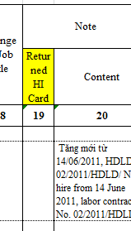

* Date type V4 report 20 TXN-TNCN use arrived date under section 3

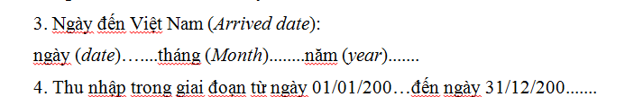

* Date type V5 report

# Payments

Based on the columns in the spreadsheet – the Vietnam specific payment settings are as follows

## Total Gross Amount – Cumulation 01

If there is an X in this column, flag the wage type to cumulate into cumulation class 01 in table V_512W_D.

## CSI Appl. Earning – Cumulation 02

If there is an X in this column, flag the wage type to cumulate into cumulation class 02 in table V_512W_D.

## VSI Appl. Earning – Cumulation 03

If there is an X in this column, flag the wage type to cumulate into cumulation class 03 in table V_512W_D.

## UI Appl. Earning – Cumulation 04

If there is an X in this column, flag the wage type to cumulate into cumulation class 04 in table V_512W_D.

## HI Appl. Earning – Cumulation 05

If there is an X in this column, flag the wage type to cumulate into cumulation class 05 in table V_512W_D.

## Taxable Income – Cumulation 06

If there is an X in this column, flag the wage type to cumulate into cumulation class 06 in table V_512W_D.

## Contract Salary – Cumulation 71

If there is an X in this column, flag the wage type to cumulate into cumulation class 71 in table V_512W_D.

The contract salary (template WT 9090) value is required for statutory social insurance and reporting purposes.

If the wage type is a “contracted salary wage type” the system will execute operation _VNCS. In cases where the contracted salary has a WPBP split the operation chooses the entry that is applicable on the 17th of the month. If there is no record for the17th the operation will return a Y for the “last active” WPBP split.

Contract Salary WT 9090 (SI applicable earnings) processing class 6 set to = 1. The last result for WT /171 is then retrieved in PCR <VM0 below:

Rule <VM0 changes (changes applicable to settings 0-2)

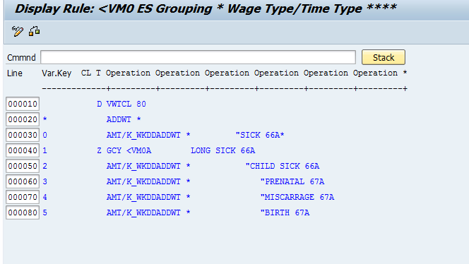

Schema –VN0 (rule <VM7 inserted for both special- and regular runs) was also changed to ensure that WT /171 is transferred when there is an off-cycle in order to be available in the LRT of the next (regular) run.

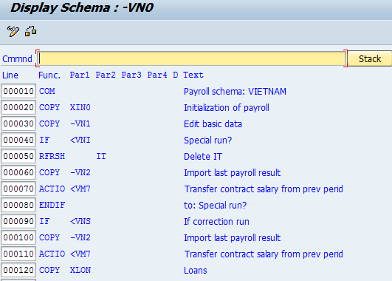

Rule <VNG changed to remove /031 (SAP standard presented a problem with rolling month processing in function AVERA. No notes available at present but will monitor situation):

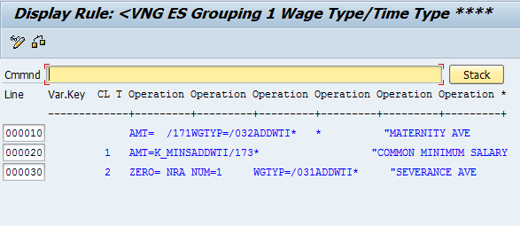

## House Rent taxable portion – Cumulation 72

If there is an X in this column, flag the wage type to cumulate into cumulation class 72 in table V_512W_D.

To be added – house rent taxable portion

House rental that the company paid to the landlord is added to his taxable income but the taxable rental amount should not exceed 15% of his total taxable income. (as per official letter_expat net income 3565 E)

The taxable income from house rental = (taxable earnings (excl. house rental) x 15% = VND

The following was created for this purpose:

V_T511K:

Constant to assign the cap percentage for tax on House rental.

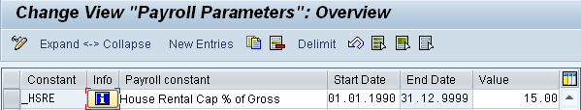

The following model wage type was created for housing rental to be captured on IT0014:

Copy M220 to Wage type 3601

The taxable portion of House rental WT captured in IT0014 cumulates into WT /172.

PCRs associated with this are:

* <VM1 – this will determine house rental capped amount, cumulates to /172
* <VM2 – this will check house rental capped amount, WT 3601 will be compared against /172 and amount added to /106

## Meal Allowance – Cumulation 76

If there is a value in this column, set the wage type to the relevant setting in processing class 76 in table V_512W_D.

Table V_T511P update constant _MEAL to calculate the value

| Constant | Payroll constant | From | To | Amounts |
| --- | --- | --- | --- | --- |
| _MEAL | Meal Allowance Tax Exemption | 01.01.2016 | 31.12.9999 | 730,000 |

## Trade Union – Cumulation 75

If there is a value in this column, set the wage type to the relevant setting in processing class 75 in table V_512W_D.

T511K Constant “ _TUEE” store Trade Union EE contribution percentage

|  |  |  |  |  |
| --- | --- | --- | --- | --- |
| _TUEE | Trade Union EE Percentage | 01.01.2014 | 31.12.9999 | 0.01 |
| _TUER | Trade Union ER Percentage | 01.01.2014 | 31.12.9999 | 0.02 |

Rule <VMH include EE contribution calculation

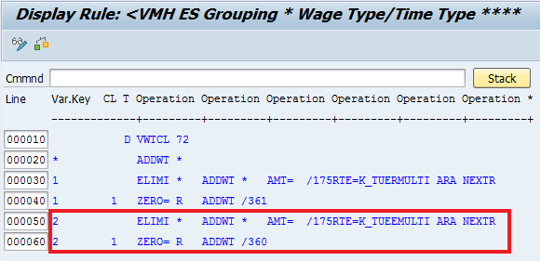

WT7301 create in the system for ER contribution calculation

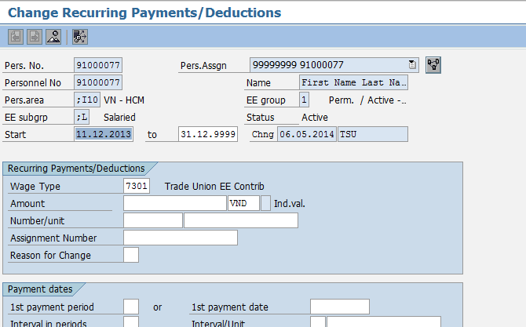

The payroll <VMI use Insurance salary /171 as base salary and store in /175 for Trade Union calculation

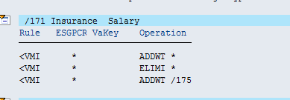

WT/360 create in the payroll for EE Trade Union deduction and reduce the net payment

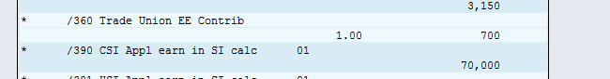

Trade Union is non-taxable deduction. The government has no guideline about new hirer or termination pro-ration. This is subject to the company policy.

## Overtime Wagetypes – Processing class 64

If there is a value in this column, set the wage type to the relevant setting in processing class 64 in table V_512W_D.

Processing class 64 indicate the wage types are to be used payroll rule <VN4

1. Other

2. Overtime or Nightshift

PCR associated with this processing class is <VN4

Please note: The premium portion of the overtime payment is tax free while the normal hourly rate component is taxable. Processing class 64 indicates the wagetypes which should follow such processing rules. Taxable amount cumulate to /106 via WT/420

Table V_T511P update constant _OTTA to calculate the value

| Constant | Payroll constant | From | To | Amounts |
| --- | --- | --- | --- | --- |
| _OTTA | Overtime Taxable Factor | 01.01.1900 | 31.12.9999 | 4 |

## AWS wagetypes – Processing class 67

If there is a value in this column, set the wage type to the relevant setting in processing class 67 in table V_512W_D.

Processing class 67 indicates the wage types are to be used as part of AWS calculation

1. Basic Salary to be considered as base of AWS

## Minimum Pay – Processing class 69

If there is a value in this column, set the wage type to the relevant setting in processing class 69 in table V_512W_D.

Processing class 69 indicate the wage types are to be used and how they are to be used as part of comparison to minimum net pay

The processing class will have 3 settings:

* 0 - ignore in user exit
* 1 - Add amount filed to total for comparison
* 2 - use amount as an hourly rate and multiply by the and multiply with work hours field (DIVGV) and add tot total for comparison.

Please note: IT0008 could store various wage type that could be regarded to form part of the employees “salary”. Some wage types on IT0008 also might be hourly wage types that carry the hourly rates for an employee.

These setting will indicate to the user exit which wage types are to be used and how they are to be used as part of the comparison to minimum net pay.

Please note this has not yet been activated in template system.

Table: V_T511P

| Constant | Payroll constant | From | To | Amounts |
| --- | --- | --- | --- | --- |
| _MNS1 | Minimum salary 1 | 01.01.2017 | 31.12.9999 | 3,750,000 |
| _MNS2 | Minimum salary 2 | 01.01.2017 | 31.12.9999 | 3,320,000 |
| _MNS3 | Minimum salary 3 | 01.01.2017 | 31.12.9999 | 2,900,000 |
| _MNS4 | Minimum salary 4 | 01.01.2017 | 31.12.9999 | 2,580,000 |

Use feature –VNMS to enforce the minimum salary for defined district, the return value for the feature is in format A-BBBBB:

**Where A** indicates whether the user exit on IT0008 must generate an message as an:

* Error - (E) or;
* Warning - (W)

**Where BBBBB** is the constant name from T511P

Example: E-MINS1

* This will ensure that the user exit on IT0008 generates an error message if the minimum salary is less than 1,000,000 VND.

Processing class 69 in T512W to identify the earnings that should be included in IT0008 for comparison against minimum salary amount

## Severance Pay – Processing class 70

If there is a value in this column, set the wage type to the relevant setting in processing class 70 in table V_512W_D.

Processing class 70 indicate the severance payment:

* 1- Add wage type to Sev/term applicable earnings - pro-ration over AP
* 2 - Add wage type to Sev/term applicable earning - no pro-ration
* 3 - Process earning as severance pay
* 4 - Process earning as termination pay

PCRs associated with this processing class 70 is <VNF and <VNK

Please note: The wagetypes which are flagged with values 1 and 2 are used to cumulate /030 which in turn calculates the averages /031 in function AVERA. For example, value 1 is assigned to WT 1101 if you wish pro-rated value to cumulate to /030, where as, value 2 should be used if you want WT 1101 NON pro-rated value to cumulate into /030.

## Other Taxable Implications – Processing class 71

If there is a value in this column, set the wage type to the relevant setting in processing class 71 in table V_512W_D.

Processing class 71 indicates the wagetypes which are used for other taxable purposes:

* 1- Exemption: Charity Humanit and Study Pro Funds - external to payroll
* 2- Exemption: Charity Humanit and Study Pro Funds - payroll deduction
* 3- House rental taxable value
* 4 – Taxable payments after termination (10% tax rate)
* 5- Exemption: Telephone charges

PCRs associated with processing class 71 are <VM2 and <VN5

Template WT 9000 Charity and Study Contrib has been assigned return value “1”, external payments.

Official Letter No. 1685 /TCT-CS providing guidance on CIT and PIT treatment for telephone expenses for employees.

Telephone charges should have the option to be setup as non-taxable if specified in a written decision from company management.

* Processing Class 71 Updated with setting 5: **Exemption:Telephone charges,** this will allow the client to setup a telephone charge as non-taxable.

Vietnam rule <VN5 updated with setting 5, this will add the Exempt telephone changes to technical Wage type /174 and reduce taxable income /106 with the non-taxable telephone charges. This processing takes place before the calculation of tax.

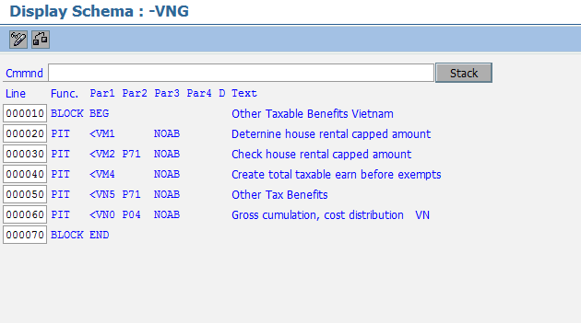

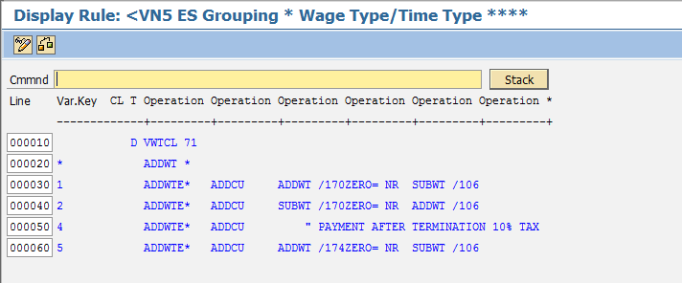

## Absence Categories for reporting – Processing class 80

If there is a value in this column, set the wage type to the relevant setting in processing class 80 in table V_512W_D.

Processing class 80 indicate the wage types are to be used for Absence Categories for Reporting

* 0 - Sick leave (66A)
* 1 - Long Sick Leave (66A)
* 2 - Child leave (66A)
* 3 - Prenatal check up (67A)
* 4 - Miscarriage, abortion, fetocytosis or stillbirth (67A)
* 5 - Giving birth or child adoption (67A)
* 6 - Contraceptive measures (67A)
* 7 - Convalescence and health rehabilitation after sickness (68A)
* 8 - Convalescence and health rehabilitation after maternity (69A)
* 9 - Convalescence and health rehabilitation after labour accident (70A)
* A – Convalescence and health rehabilitation in Rest Home after sickness (68A)
* B – Convalescence and health rehabilitation in Rest Home after accident (70A)

PCR associated with this processing class is <VM0.

## Year of Service processing – Processing class 83

Processing class 83 YOS upload

* 1-YOS upload value
* 2- YOS correction value

## Window on Payslip

If there is a value in this column, set the wage type to the relevant setting in evaluation class 02 in table V_512W_D.

# Pay Scale Structure

## IMG Path & Table: Define EE Subgroup Grouping for PCR and Collective Agreement Provision (CAP).

Path: Personnel Management 🡪 Personnel Administration 🡪 Payroll Data 🡪 Basic Pay 🡪 Define EE Subgroup Grouping for PCR and Collective Agreement Provision.

Table: V_503_B

In this step, you can define the groupings for the personnel calculation rules and collective agreement provisions for all your employee groups and subgroups.

| EEGrp | ESgrp | CGrpg | Name of employee grp | Name of EE subgrp | ESGPCR | Grpg |
| --- | --- | --- | --- | --- | --- | --- |
| 1 | ;I | VN | Perm. / Active - FT | Hourly rate | 1 | 1 |
| 1 | ;M | VN | Perm. / Active - FT | Management | 3 | 1 |
| 1 | ;L | VN | Perm. / Active - FT | Salaried | 3 | 1 |
| 2 | ;I | VN | Pensioners | Hourly rate | 1 | 1 |
| 2 | ;L | VN | Pensioners | Salaried | 3 | 1 |
| 3 | ;L | VN | Temporary - FT | Salaried | 3 | 1 |
| 4 | ;L | VN | Temporary - PT | Salaried | 3 | 1 |
| 8 | ;I | VN | Contractor-Direct | Hourly rate | 1 | 1 |
| 9 | ;I | VN | Contractor-3rd Party | Hourly rate | 1 | 1 |
| A | ;I | VN | Apprentice | Hourly rate | 1 | 1 |
| A | ;L | VN | Apprentice | Salaried | 3 | 1 |
| C | ;I | VN | Casual | Hourly rate | 1 | 1 |
| C | ;L | VN | Casual | Salaried | 3 | 1 |
| E | ;L | VN | Early-retiree | Salaried | 3 | 1 |
| I | ;L | VN | Inpats | Salaried | 3 | 1 |
| P | ;L | VN | Permanent - PT | Salaried | 3 | 1 |
| S | ;L | VN | Seasonal | Salaried | 3 | 1 |
| T | ;L | VN | Trainee | Salaried | 3 | 1 |
| X | ;L | VN | Expats | Salaried | 3 | 1 |
| Z | ;L |  | Cross-border | Salaried | 3 | 1 |

The employee subgroup grouping for the personnel calculation rule is required in Payroll Accounting. The collective agreement provisions grouping is required for indirect valuation of wage types in the Basic Pay infotype (0008).

**Example**

Employee subgroup grouping for the personnel calculation rule:

* The personnel calculation rule allows one wage type to be processed in different ways in payroll accounting.
* The value of the standard pay wage type should be used as a basis of valuation for hourly wage earners. The value of the standard pay wage type should be divided by the planned working hours before being used as a basis of valuation for salaried employees.

Employee subgroup grouping for collective agreement provisions:

* A standard agreement designates the same pay scale groups and levels for both hourly wage earners and salaried employees; however, the user must still be able to enter hourly or monthly values in the pay scale table

## IMG Path & Table: Payscale Conversion for Basic Pay

Path: Personnel Management 🡪 Personnel Administration 🡪 Payroll Data 🡪 Basic Pay 🡪 Payscale Conversion for Basic Pay

Table: T546

| ESGPCR | Grpg | R |
| --- | --- | --- |
| 1 | 1 |  |
| 1 | 2 | 2 |
| 3 | 0 |  |
| 3 | 1 | 1 |
| 3 | 2 |  |

In this step, you can define whether, and if so how, indirect valuation of wage types in the pay scale table should be changed for display in the Basic Pay infotype (0008).

The aim is to define a so-called reaction indicator for each grouping for the personnel calculation rule and collective agreement provisions. The reaction indicator is then used to convert the table value to a monthly or hourly value, or vice versa, depending on the specification.

**Example**

**Convert an hourly value to a monthly value**

The following groupings apply to your employee A:

* Grouping for the collective agreement provisions = 1 (industrial workers/hourly wage)
* Grouping for the personnel calculation rule = 2 (periodic payment - for example, monthly wage earners)

In this case the reaction indicator is '1'.

**Convert a monthly value to an hourly value**

* The following groupings apply to your employee B:
* Grouping for the collective agreement provisions = 2 (industrial workers/monthly wage)
* Grouping for the personnel calculation rule = 1 (hourly wage earners)

In this case the reaction indicator is '2'.

## IMG Path & Table: Check Pay Scale Type

Path: Personnel Management 🡪 Personnel Administration 🡪 Payroll Data 🡪 Basic Pay 🡪 Check Pay Scale Type.

Table: V_T510A

| CGrpg | Ty. | PS type | IP |
| --- | --- | --- | --- |
| VN | 01 | Payscale Type 1 |  |

In this step you set up your enterprise's collective agreement types (pay scale types for short). The Basic Pay in infotype 0008 is derived from the pay scale type. By using the internal key, you can assign a fixed internal mean for evaluations to optional pay scale types.

**Example**

Two collective agreement types are valid - type "01" for the metal industry and "02" for your inhouse agreement.

## IMG Path & Table: Check Pay Scale Area

Path: Personnel Management 🡪 Personnel Administration 🡪 Payroll Data 🡪 Basic Pay 🡪 Check Pay Scale Area.

Table: V_T510G

| CGrpg | PSA | PS area text |
| --- | --- | --- |
| VN | 01 | VN - Monthly |

In this section, you set up different collective agreement areas (pay scale areas for short) in accordance with the collective agreement in your enterprise.

**Example**

You want to assign the indicator "01" to a particular pay scale area.

## IMG Path & Table: Check Assignment of Payscale Structure to Enterprise Structure

Path: Personnel Management 🡪 Personnel Administration 🡪 Payroll Data 🡪 Basic Pay 🡪 Assignment of Payscale Structure to Enterprise Structure

Table: V_001P_C

| PA | PSubarea | CGrpg | PA text | PS text | PSA | PS area | Ty. | PS type |
| --- | --- | --- | --- | --- | --- | --- | --- | --- |
| ;I10 | 0001 | VN | VN - HCM | PSA 1 |  |  |  |  |
| ;I10 | 0002 | VN | VN - HCM | PSA 2 |  |  |  |  |
| ;I10 | 0003 | VN | VN - HCM | PSA 3 |  |  |  |  |
| ;I20 | 0001 | VN | VN - Hanoi | PSA 1 |  |  |  |  |
| ;I20 | 0002 | VN | VN - Hanoi | PSA 2 |  |  |  |  |
| ;I20 | 0003 | VN | VN - Hanoi | PSA 3 |  |  |  |  |

In this step, you assign collective agreement types and areas (pay scaletypes and areas for short) to your personnel areas.

**Example**

Your personnel area "0001" is assigned pay scale area "01" and pay scale type "01" (metal industry).

Note: You do not need to enter any values in this table for the Pay Scale type or Area. This information can be obtained through function TARIF.

## IMG Path & Table: Define Default for Pay Scale Data

Path: Personnel Management 🡪 Personnel Administration 🡪 Payroll Data 🡪 Basic Pay 🡪 Define Default for Pay Scale Data

Feature: TARIF

In this step, you define how default values are determined for collective agreement types and areas (pay scale types and areas for short).

**Example**

You can either define these default values using the pay scale area and type assigned to the personnel area, or a feature.

## IMG Path & Table: Set up payroll period for Collective Agreement Provision

Path: Personnel Management 🡪 Personnel Administration 🡪 Payroll Data 🡪 Basic Pay 🡪 Set up payroll period for Collective Agreement Provision

Table: V_T510W

| CGrpg | Ty. | PSA | Grpg | PerPa | PS type | PS area text | Name | End Date |
| --- | --- | --- | --- | --- | --- | --- | --- | --- |
| VN | 01 | 01 | 1 | 44 | Hourly Rate | Payscale Type 1 | VN - Monthly | 31/12/9999 |
| VN | 01 | 01 | 3 | 44 | Salaried | Payscale Type 1 | VN - Monthly | 31/12/9999 |

In this step, you create the default value for the working hours per period.

The default value for the working hours per period for the infotype Basic Pay (0008) is determined by the infotype Planned Working Time (0007). This is based on a monthly working time, i.e. the period is a month.

It may be necessary to enter an amount here that is valid for another period, for example, for a weekly wage. The system will then suggest the default value for the working hours per period.

You only have to complete this step if a monthly payroll period does not apply to all of the employees in your enterprise.

**Example**

Some employees are paid weekly, others are paid monthly.

The correct number of hours per period must be suggested as default values for everyone in the infotype *Basic Pay* (0008).

**Standard Settings**

In the standard SAP system, a period is a month, i.e. the feature **U510F** has the value "Blank".

No entries have been made in the view *Assign Pay Scale -> Period Parameter*.

A blank entry is interpreted as "monthly".

## IMG Path & Table: Define Hourly Rates with Several Decimal Places

Path: Personnel Management 🡪 Personnel Administration 🡪 Payroll Data 🡪 Basic Pay 🡪 Define Hourly Rates with Several Decimal Places

Table: V_T510F_B

| CGrpg | Ty. | PSA | Grpg | Crcy | PS type | PS area text | End Date |
| --- | --- | --- | --- | --- | --- | --- | --- |
| VN | 01 | 01 | 1 | VND | Hourly Rate | VN - Monthly | 31/12/9999 |
| VN | 01 | 01 | 3 | VND | Salaried | VN - Monthly | 31/12/9999 |

In this step, you define an alternative currency to be used for wage type amounts in the infotype Basic Pay (0008).

The default currency for wage types in the infotype Basic Pay (0008) is taken from the currency set for the company code in the Currency for Public Sector view. You can, however, set up the default currency so that it is dependent on the country grouping, pay scale type, pay scale area and employee subgroup grouping for collective agreement provision.

You can also set up a currency with additional decimal places. This allows you to enter amounts for wage types that have more than the usual number of decimal places.

The currency for the annual salary should still be taken from the Currency for Public Sector view.

## IMG Path & Table: Revise Pay Scale Groups and Levels

Path: Personnel Management 🡪 Personnel Administration 🡪 Payroll Data 🡪 Basic Pay 🡪 Revise Pay Scale Groups and Levels

Table: V_T510

| CGrpg | Ty. | PSA | Grpg | PS group | Lv | WT | Pay scale type text | Pay scale area text | End Date | Start Date | Amount |
| --- | --- | --- | --- | --- | --- | --- | --- | --- | --- | --- | --- |
| VN | 01 | 01 | 1 | SALARY |  | 1401 | Hourly Rate | VN - Monthly | 31/12/9999 | 01/01/1990 | 0.00 |
| VN | 01 | 01 | 3 | SALARY |  | 1101 | Salaried | VN - Monthly | 31/12/9999 | 01/01/1990 | 0.00 |

In this step, you represent the collective agreement governing payment of your employees in the SAP system.

**Example**

You would like to enter wage types in the *Basic Pay* infotype (0008) which should be valuated indirectly using the pay scale groups/levels

## IMG Path & Table: Specify Working Hours fixed by Collective Agreement

Path: Personnel Management 🡪 Personnel Administration 🡪 Payroll Data 🡪 Basic Pay 🡪 Specify Working Hours fixed by Collective Agreement

Table: V_T510I

| CGrpg | Ty. | PSA | Grpg | Hours | Days | PS type | PS area text | End Date | Start Date |
| --- | --- | --- | --- | --- | --- | --- | --- | --- | --- |
| VN | 01 | 01 | 1 | 4000 | 5 | Hourly Rate | VN - Monthly | 31/12/9999 | 01/01/1990 |
| VN | 01 | 01 | 3 | 4000 | 5 | Salaried | VN - Monthly | 31/12/9999 | 01/01/1990 |

In the last step, you defined the collective agreement types (pay scale types for short) and collective agreement areas (pay scale areas for short) for your enterprise.

You now assign working times to your various combinations of pay scale type and pay scale group. You specify both the standard weekly working time and the standard number of working days per week as stipulated in the collective agreement.

**Example**

Employees assigned to the pay scale type 'metal industry' and the pay scale area 'Rhineland-Palatinate' have a standard weekly working time of 36.50 hours; the hours are distributed over 5 working days.

## IMG Path & Table: Revise Default Wage Types

Path: Personnel Management 🡪 Personnel Administration 🡪 Payroll Data 🡪 Basic Pay 🡪 Wage Types 🡪 Revise Default Wage Types

Table: V_T539A

| CGrpg | WT model | No | Wage type | Mod | Wage type text | End date | Start date |
| --- | --- | --- | --- | --- | --- | --- | --- |
| VN | SALARY | 01 | 1101 | O | Monthly salary | 31/12/9999 | 01/01/1998 |
| VN | HOURLY | 01 | 1401 | O | Hourly Rate | 31/12/9999 | 01/01/1998 |

In this step, you can set up default wage types based on your internal company structure for the *Basic Pay* infotype (0008) using the feature **Planned remuneration specification** (LGMST) defined in the previous step.

**Example**

You want the system to propose the wage type "standard pay" for salaried employees and industrial workers in all personnel areas. So you assigned the key "----1DU" to these two employee subgroups in the previous step. In this step, you determine the default wage type "standard pay" for this key.

## IMG Path & Table: Enterprise Structure for Wage Type Model

Path: Personnel Management 🡪 Personnel Administration 🡪 Payroll Data 🡪 Basic Pay 🡪 Wage Types 🡪 Enterprise Structure for Wage Type Model.

Feature: LGMST

When your company hires new employees or transfers employees from one department to another, the system proposes wage types in the *Basic Pay* infotype (0008). These default values often depend on the personnel area and/or employee group/subgroup.

For a better understanding of the procedure, read the next step before performing this one.

In this step, you can define the key for default wage types in accordance with the above conditions.

The actual wage types are defined in the next section.

If you want to define default wage types for some, but not all, employee subgroups, group those employee subgroups with the same default wage types with this feature. This saves you work in the next step.

**Example**

The *Basic Pay* infotype (0008) should propose the wage type "standard pay" for pay scale employees, and "non-standard salary" for non-pay-scale employees, when you hire an employee or transfer employees to another department.

## IMG Path & Table: Define Valuation of Base Wage Types

Path: Personnel Management 🡪 Personnel Administration 🡪 Payroll Data 🡪 Basic Pay 🡪 Wage Types 🡪 Define Valuation of base Wage types.

Table: V_T539J

| Mod.name | CGrpg | Wage type | No | Wage type | Wage type text | Wage type text | End date | Start date |  |
| --- | --- | --- | --- | --- | --- | --- | --- | --- | --- |
| ANSAL | VN | ASAL | 01 | 1401 | Hourly Rate | Annual Salary | 31/12/9999 | 12/01/1900 | 100.00 |
| ANSAL | VN | ASAL | 02 | 1101 | Monthly Salary | Annual Salary | 31/12/9999 | 13/01/1900 | 100.00 |
| ANSAL | VN | ASAL | 02 | 1101 | Monthly Salary | Annual Salary | 31/12/9999 | 13/01/1900 | 100.00 |

You may have already defined indirect valuation for certain wage types in the step " Check wage type characteristics".

Depending on which module you use for indirect valuation (see documentation on the Module name field), you need to define additional procedures to ensure that indirect valuation functions correctly.

**Example**

In the Basic Pay infotype (0008), an employee has the wage types 'standard pay' and 'standard bonus'. You also want to assign to your employee the wage type 'percentage bonus' which should be x% of the sum of the first two wage types.

You have defined the module PRZNT for the 'percentage bonus' wage type.

In this step, you must define the wage types to be used as the basis for calculating the percentage bonus

# Rates of Pay

Rates of pay will be derived from the wage types specified in tab. The Rates will be calculated through payroll rules X010 & X013.

**PCR: X010**

Procedure

Calculation rule X010 queries the wage types for processing class 01. The wage type is used in different valuation bases depending on the specification for the processing class.

Processing class 01 must be maintained in table T512W for all wage types listed in the "Basic Pay" infotype (0008). If a wage type is not to be used in a valuation basis, you must set specification 0. Wage types not listed in the "Basic Pay" infotype (0008) can be transferred unchanged by the calculation rule by using the employee subgroup grouping for personnel calculation rule * and specification 0 in processing class 01. Calculation rule =113 must be processed directly after =110 in the schema

**PCR: X013**

Rule X013 queries the entry for processing class 01 in the wage types. The basic pay wage types are passed on directly. Valuation bases /001 and /002, which are calculated by adding the basic pay in calculation rule =110, are divided by the lump sum hourly value.

This rule must be processed directly after rule =110 in the schema. Processing class 01 must be maintained in table T512W for all wage types entered in the 'Basic Pay' infotype (0008). The value 5 must be set in processing class 01 for the two valuation bases. Wage types that are not entered in the "Basic Pay" infotype (0008) can be transferred unchanged using employee subgroup grouping for personnel calculation rule * and specification 0 in processing class 01.

# Pro-Rata and Factoring

Factoring is calculated through payroll rune =VN1. This rule will factor the wage types specified by the different factoring options available.

**PCR: =VN1**

Personnel calculation rule =VN1 is used with rules =VN2, =VN3 and =VN4 to determine the correct values for partial period factors. Until now, these values were set to '1' using function GEN/8. These rules carry out Calculation rule =VN1 checks whether the employee has inactive work relationship throughout the period. If this is not the case, rule =VN2 determines whether the situation would result in a value other than ‘1’ for the partial period factor. If this is not the case, the wage type is stored unchanged in table OT. Otherwise, the appropriate value is determined in rule =VN3 based on attendance and absence data.

# Deductions

Based on the columns in the spreadsheet – the Vietnam specific deduction settings are as follows

## Total Deductions

If there is an X in this column, flag the wage type to cumulate into cumulation class 10 in table V_512W_D.

## VSI Appl. Earning

If there is an X in this column, flag the wage type to cumulate into cumulation class 03 in table V_512W_D.

## UI Appl. Earning

If there is an X in this column, flag the wage type to cumulate into cumulation class 04 in table V_512W_D.

## HI Appl. Earning

If there is an X in this column, flag the wage type to cumulate into cumulation class 05 in table V_512W_D.

## Taxable Income

If there is an X in this column, flag the wage type to cumulate into cumulation class 06 in table V_512W_D.

## Double Tax Amount

If there is an X in this column, flag the wage type to cumulate into cumulation class 07 in table V_512W_D.

## SI Employee Payment

If there is an X in this column, flag the wage type to cumulate into cumulation class 11 in table V_512W_D.

## Annual Payment taxable

If there is an X in this column, flag the wage type to cumulate into cumulation class 21 in table V_512W_D.

## Window on Payslip

If there is a value in this column, set the wage type to the relevant setting in evaluation class 02 in table V_512W_D.

# Holiday Calendar

## IMG Path & Table: Define Public Holiday Classes

Path: Personnel Time Management 🡪 Work Schedules 🡪 Define Public

In this step, you assign **public holiday classes** to the holidays defined in the **public holiday calendar**.

**Requirements**

You have defined public holiday calendars. The public holiday calendar for Vietnam must commence with the number ‘;I’ which is the ADP country identifier for Vietnam.

See also <https://wiki.au.adp.com/wiki/bin/view/GlobalView/ClientSpecificHolidayCalendars>

# Work Patterns

## IMG Path & Table: Define Break Schedules

Path: Personnel Time Management 🡪 Work Schedules 🡪 Daily Work Schedules 🡪 Define Break Schedules

Table: V_T550P

| Grpg | Break | No | Start | End | P | B1 | B2 | RefTim | Paid | Unpaid | After |
| --- | --- | --- | --- | --- | --- | --- | --- | --- | --- | --- | --- |
| 98 | C300 | 01 | 12:00:00 | 12:30:00 |  |  |  |  | 0.00 | 0.50 | 0.00 |
| 98 | C305 | 01 | 12:00:00 | 12:30:00 |  |  |  |  | 0.50 | 0.00 | 0.00 |
| 98 | C600 | 01 | 12:00:00 | 13:00:00 |  |  |  |  | 0.00 | 1.00 | 0.00 |
| 98 | C605 | 01 | 12:00:00 | 13:00:00 |  |  |  |  | 1.00 | 0.00 | 0.00 |
| 98 | D300 | 01 | 13:00:00 | 13:30:00 |  |  |  |  | 0.00 | 0.50 | 0.00 |
| 98 | D305 | 01 | 13:00:00 | 13:30:00 |  |  |  |  | 0.50 | 0.00 | 0.00 |
| 98 | D600 | 01 | 13:00:00 | 14:00:00 |  |  |  |  | 0.00 | 1.00 | 0.00 |
| 98 | D605 | 01 | 13:00:00 | 14:00:00 |  |  |  |  | 1.00 | 0.00 | 0.00 |
| 98 | I300 | 01 | 18:00:00 | 18:30:00 |  |  |  |  | 0.00 | 0.50 | 0.00 |
| 98 | I305 | 01 | 18:00:00 | 18:30:00 |  |  |  |  | 0.50 | 0.00 | 0.00 |
| 98 | I600 | 01 | 18:00:00 | 19:00:00 |  |  |  |  | 0.00 | 1.00 | 0.00 |
| 98 | I605 | 01 | 18:00:00 | 19:00:00 |  |  |  |  | 1.00 | 0.00 | 0.00 |

In this step, you define work break schedules for your enterprise. You can specify exactly when breaks may be taken within the daily work schedule, and whether they are paid or unpaid.

**Example**

One day shift has a coffee break from 9:00 to 9:15 a.m. and a lunch break from 12:30 to 1:00 p.m. (work break schedule DAY1). Another shift has a coffee break from 9:15 to 9:30 a.m. (from/to) and a 30-minute lunch break which may be taken between 12:00 noon and 1:30p.m. (break periods are specified in industry minutes). This would be work break schedule DAY2.

## IMG Path & Table: Define Rules for Variants

Path: Personnel Time Management 🡪 Work Schedules 🡪 Daily Work Schedules 🡪 Define Rules for Variants

Table: V_T550X

| RT | Rule | No | Holiday | Next day | Weekday | V |
| --- | --- | --- | --- | --- | --- | --- |
| 01 | 01 | 01 | 0010000000 | 1111111111 | 1111111 | B |
| 01 | 01 | 02 | 1101111111 | 1111111111 | 0000100 | B |

In this step, you can define rules for daily work schedules. The rules allow you to stipulate that a variant of the daily work schedule should apply on certain days. Taking the following parameters into account, you can set up rules for daily work schedule variants:

* The public holiday class of the current day
* The public holiday class of the next day
* Weekday

**Example**

A number of employees in your enterprise work Monday through Thursday from 8 a.m. to 4.45 p.m., and from 8 a.m. to 2 p.m. on Fridays. The daily work schedule for Fridays is derived using the daily work schedule selection rule 01 with variant A.

## IMG Path & Table: Define Daily Work Schedules

Path: Personnel Time Management 🡪 Work Schedules 🡪 Daily Work Schedules 🡪 Define Daily Work Schedules.

Table: V_T550A

| Grpg | DWS | V | SeqNo | Daily WS text | DWSCl | NoBeg | NoEnd | Work Start | Work end | Break | End Date | Start Date | Plnd hrs |
| --- | --- | --- | --- | --- | --- | --- | --- | --- | --- | --- | --- | --- | --- |
| 98 | 8750 |  | 01 | 8:30, 7.5 Hr/d | 1 | 08:30:00 | 17:00:00 | 00:00:00 | 24:00:00 | D600 | 31/12/9999 | 01/01/1990 | 7.50 |
| 98 | 8800 |  | 01 | 8:30, 8 Hr/d | 1 | 08:30:00 | 17:00:00 | 00:00:00 | 24:00:00 | C300 | 31/12/9999 | 01/01/1990 | 8.00 |
| 98 | 8801 |  | 01 | 8:30, 8 Hr/d | 1 | 08:30:00 | 17:30:00 | 00:00:00 | 24:00:00 | C600 | 31/12/9999 | 01/01/1990 | 8.00 |
| 98 | 9800 |  | 01 | 9:00, 8 Hr/d | 1 | : : | : : | 09:00:00 | 17:00:00 | C305 | 31/12/9999 | 01/01/1990 | 8.00 |
| 98 | 9801 |  | 01 | 9:00, 8 Hr/d | 1 | : : | : : | 09:00:00 | 18:00:00 | C600 | 31/12/9999 | 01/01/1990 | 8.00 |
| 98 | FLEX |  | 01 | Flexible Time | 1 | : : | : : | 00:00:00 | 08:00:00 |  | 31/12/9999 | 01/01/1990 | 8.00 |

In this step, you define daily work schedules for your enterprise. By entering the planned working time, the system calculates the planned planned hours for one day, taking the break schedule into consideration.

You also define daily work schedules for availability in this step. For more information, see Determine Daily Work Schedules for Availability.

**Example**

* Employees in your enterprise who work the day shift on Monday work from 8:00 a.m. to 4:45 p.m. The work break schedule includes a 45-minute break. Thus, the resulting number of planned working hours for this day 8 (basic variant of the daily work schedule). You call this daily work schedule DAY1. On Friday, the same day shift only works from 8:00 a.m. to 2:30 p.m., including a 30-minute break. The work schedule for Friday is a variant of the daily work schedule DAY1. Call this daily work schedule DAY with variant A.
* Different wage types should be generated for daily work schedules that define a rotating shift. Group together the daily work schedules defining a rotating shift to the same daily work schedule class.

## IMG Path & Table: Define Period Work Schedules

Path: Personnel Time Management 🡪 Work Schedules 🡪 Period Work Schedules 🡪 Define Daily Work Schedules

Table: V_T551A

| Grpg | PWS | Week | DWS | Period WS text | DWS | DWS | DWS | DWS | DWS | DWS |
| --- | --- | --- | --- | --- | --- | --- | --- | --- | --- | --- |
| 98 | 1S00 | 001 | 8800 | Standard | 8800 | 8800 | 8800 | 8800 | OFF | OFF |
| 98 | 1S01 | 001 | 8750 | Standard 37.5 hrs | 8750 | 8750 | 8750 | 8750 | OFF | OFF |
| 98 | 2X00 | 001 | 8800 | 2 Mixed 32 hr/w | 8800 | 8800 | 8800 | OFF | OFF | OFF |
| 98 | 2X00 | 002 | OFF | 2 Mixed 32 hr/w | 8800 | 8800 | 8800 | 8800 | OFF | OFF |

## IMG Path & Table: Set Work Schedule Rules and Work Schedules

Path: Personnel Time Management 🡪 Work Schedules 🡪 Work Schedule Rules and Work Schedules 🡪 Set Work Rules and Work Schedules.

Table: V_T508A

| ESG | ID | PSG | WS rule | Work schedule rule text | Text | PWS | Pt | Grpg | Rule | Ref. date | Wk.hrs | Wk.hrs. | MoHrs | Wk.dys | AnnualHrs |
| --- | --- | --- | --- | --- | --- | --- | --- | --- | --- | --- | --- | --- | --- | --- | --- |
| 1 | ;I | 98 | S537500 | Standard 5d, 37.5 hrs | ADP - Vietnam | 1S01 | 001 | 98 | 01 | 01/01/1990 | 7.50 | 37.50 | 162.50 | 5.00 | 1,950.00 |
| 1 | ;I | 98 | S540000 | Standard 5d, 40 hrs | ADP - Vietnam | 1S00 | 001 | 98 | 01 | 01/01/1990 | 8.00 | 40.00 | 173.33 | 5.00 | 2,080.00 |
| 1 | ;I | 28 | X432000 | Mixed 4d, 32 hrs | ADP - Vietnam | 2X00 | 001 | 98 | 01 | 01/01/1990 | 8.00 | 32.00 | 138.67 | 4.00 | 1,664.00 |

In this step, you define the work schedule rules that are assigned to employees in the Planned Working Time infotype (0007). The employee subgroup and personnel subarea groupings for work schedules and the public holiday calendar are taken into account.

**Example**

In your enterprise, employees in the "monthly wage earner" subgroup in personnel area 0001 work an early shift one week and a late shift the next week. The early shift work schedule is assigned the work schedule rule "2WEARL", the late shift work schedule is assigned work schedule rule "2WLATE". The period work schedule "2W" is entered in both work schedule rules.

## IMG Path & Table: Generate Work Schedules in Batch

Path: Personnel Time Management 🡪 Work Schedules 🡪 Work Schedule Rules and Work Schedules 🡪 Generate Work Schedules in Batch.

You must generate and transport the work schedules once they are complete.

# Absences

## IMG Path & Table: Define Absence Types

Path: Personnel Time Management 🡪 Time Data Processing and Administration 🡪 Absences 🡪 Absence Catalog 🡪 Define Absence Types

Table: V_T554S

| PSG | A/AType | Att./abs. type text | D | F | L | NP | I | U | End Date | Start Date | Min. | Max. |
| --- | --- | --- | --- | --- | --- | --- | --- | --- | --- | --- | --- | --- |
| 98 | 1000 | Annual Leave |  | E | E | E | A |  | 31/12/9999 | 01/01/1900 | 0 | 999 |
| 98 | 3000 | LWOP |  | E | E | E | A | R | 31/12/9999 | 01/01/1900 | 0 | 10 |
| 98 | 4000 | Personal leave with Pay |  | E | E | E | A | R | 31/12/9999 | 01/01/1900 | 1 | 10 |
| 98 | 4001 | Personal leave w/o Pay |  | E | E | E | A | R | 31/12/9999 | 01/01/1900 | 0 | 5 |
| 98 | 2811 | Sick Leave |  | W | W | E |  | R | 31/12/9999 | 01/01/1900 | 0 | 999 |
| 98 | 2812 | Long sick Leave |  | W | W | E |  | R | 31/12/9999 | 01/01/1900 | 0 | 999 |
| 98 | 2813 | Child leave |  | W | W | E |  | R | 31/12/9999 | 01/01/1900 | 0 | 999 |
| 98 | 2814 | Prenatal check-up |  | W | W | E |  | R | 31/12/9999 | 01/01/1900 | 0 | 999 |
| 98 | 2815 | Miscarriage abortion |  | W | W | E |  | R | 31/12/9999 | 01/01/1900 | 0 | 999 |
| 98 | 2816 | Child birth or Adopt |  | W | W | E |  | R | 31/12/9999 | 01/01/1900 | 0 | 999 |
| 98 | 2817 | Contraceptive measure |  | W | W | E |  | R | 31/12/9999 | 01/01/1900 | 0 | 999 |
| 98 | 2818 | Conval sick home |  | W | W | E |  | R | 31/12/9999 | 01/01/1900 | 0 | 999 |
| 98 | 2819 | Conval sick resthome |  | W | W | E |  | R | 31/12/9999 | 01/01/1900 | 0 | 999 |
| 98 | 2820 | Conval mat home |  | W | W | E |  | R | 31/12/9999 | 01/01/1900 | 0 | 999 |
| 98 | 2821 | Conval mat rest home |  | W | W | E |  | R | 31/12/9999 | 01/01/1900 | 0 | 999 |
| 98 | 2822 | Conval injury home |  | W | W | E |  | R | 31/12/9999 | 01/01/1900 | 0 | 999 |
| 98 | 2823 | Conval inj rest home |  | W | W | E |  | R | 31/12/9999 | 01/01/1900 | 0 | 999 |

In this step, you define absence types for your different personnel subarea groupings . You can also define the checks the system performs when you enter an absence.

**Example**

You want to define the Educational leave absence type for a particular personnel subarea grouping. When this absence is recorded for an employee and the start or end date is a day off, the system should reject the entry.

## IMG Path & Table: Define Counting Classes for the Period work Schedule

Path: Personnel Time Management 🡪 Time Data Processing and Administration 🡪 Absences 🡪 Absence Catalog 🡪 Absence Counting 🡪 Define Counting classes for the period work schedule.

Table: V_T551C

| Grpg | PWS | Week | Description | Cl. | End Date | Start Date |
| --- | --- | --- | --- | --- | --- | --- |
| 98 | 1S00 | 001 | Standard | 1 | 31/12/9999 | 01/01/1990 |
| 98 | 1S01 | 001 | Standard 37.5 hrs | 1 | 31/12/9999 | 01/01/1990 |
| 98 | 2X00 | 001 | 2 Mixed 32 hr/w | 1 | 31/12/9999 | 01/01/1990 |

In this step, you define counting classes for your period work schedules, which are used to valuate attendances and absences. You can query the class in Define Rules for Absence Counting.

Use different counting classes for period work schedules with very long daily work schedules (10 hours) and many days off. In this case, more than 1.00 leave days is calculated for each workday.

**Example**

According to a company ruling, one day of leave should be calculated per workday for a particular employee group. Assign counting class 1 to this group's period work schedule. Another employee group is to be credited with 1.25 leave days for each workday. Assign counting class 2 to their period work schedule.

When you maintain counting rules, you must define a separate rule for each class.

## IMG Path & Table: Define Counting Rules

Path: Personnel Time Management 🡪 Time Data Processing and Administration 🡪 Absences 🡪 Absence Catalog 🡪 Absence Counting 🡪 Rules for Absence Counting (New) 🡪 Define Counting Rules

Table: T556C

| ESG | PSGpg | Rule | Description | Weekday | Holiday | Cntg class | DWS class | Day type | FP | Rule | Multi | Multi |
| --- | --- | --- | --- | --- | --- | --- | --- | --- | --- | --- | --- | --- |
| 1 | 98 | 100 | ADP - Standard Attendance counting | XXXXXXX | XXXXXXXX | XXXXXXXXXX | XXXXXXXXX | X | XX | 001 | 100.00 | 100.00 |

In this step, you define rules for counting attendances and absences. The rules are used to determine the payroll days and hours for an attendance or absence. The payroll days and hours that have been counted are used to control the deduction of quotas. They can be used in Payroll to valuate the absence.

## IMG Path & Table: Define Deduction Rules

Table: V_556R_B

| ESG | PSGpg | QType | Rule | Description | TMU | Quota | Deduction seq. | NQuot | Sort | Sort | Sort | Sort | End Date | Start Date |
| --- | --- | --- | --- | --- | --- | --- | --- | --- | --- | --- | --- | --- | --- | --- |
| 1 | 98 | A | 010 | Annual Leave (VN) | 010 | 1 | 50 | 0 | 1 | 1 | 1 | 1 | 31/12/9999 | 01/01/1990 |

In this step, you specify conditions for the evaluation day, the work schedule, and the attendance or absence. These conditions must be fulfilled for a counting rule to be selected. You also define default values for the counting of attendances and absences. The most important default is the percentage value used to calculate the payroll hours or days from the attendance or absence hours or days. You enter the percentage in the Quota multiplier field. You can define a quota multiplier for the hours and for the days. You will normally enter the same percentage values here. However, in certain circumstances, you may want to count absences differently for quota deduction and for valuation in Payroll. You can do this as long as you use a different unit for deducting the absence than for valuating the absence in Payroll. (Absence valuation ). This means that you can, for example, use the payroll hours for quota deduction, and the payroll days for absence valuation to determine average values.

**Structure of the counting rules**

A counting rule can comprise several individual sub-rules. The sub-rules are numbered sequentially. The system runs through the individual sub-rules until it finds a rule that applies.

You can specify several conditions that must all be fulfilled for a rule to apply. You indicate that a condition must be fulfilled by selecting the relevant field.

**Example**

In your enterprise, employees receive an annual entitlement of five days for further training. For each employee, an attendance quota of five days is created in the Attendance Quotas infotype (2007). The attendance type Further training is used to deduct from the quota.

Seminars are not normally held on public holidays. Some of your employees, however, must work on public holidays. You therefore do not want public holidays to be deducted from the quota for attendance type Further training.

You therefore select in the Holiday class area the Not a public holiday field and in the Day type area the Work acc. to work schedule field. In the Condition for the planned hours area, select the Planned hours > 0 field.

**Example**

An employee group works 40 hours a week, but not 5 days a week as usual, but 4 days a week for 10 hours a day. Like their other colleagues, they have a leave entitlement of 20 days a year. The period work schedule assigned to this employee group is allocated the counting class for the period work schedule 05.

A leave day for these employees is worth 1.25 days, that is, 1.25 days must be deducted from their leave entitlement for each leave day.

You can query the counting class of the period work schedule when you count absences. In this way , you can define a rule that only applies to work schedules assigned the counting class for the period work schedule 05. As well as other data on the public holiday class, weekday, and so on, you enter a quota multiplier for hours or a quota multiplier for days of 125 %.

## IMG Path & Table: Assign Counting Rules to Absence Types

Path: Personnel Time Management 🡪 Time Data Processing and Administration 🡪 Absences 🡪 Absence Catalog 🡪 Absence Counting 🡪 Assign Counting Rules to Absence Types

Table: V_554S_Q

| PSG | A/AType | Att./abs. type text | QTy. | Grpg | I | M | Rule | Ded | End Date | Start Date |
| --- | --- | --- | --- | --- | --- | --- | --- | --- | --- | --- |
| 98 | 1000 | Annual Leave | 00 | 00 | A |  | 100 | X | 31/12/9999 | 01/01/1900 |
| 98 | 3000 | LWOP | 00 | 00 | A |  | 100 | X | 31/12/9999 | 01/01/1900 |
| 98 | 4000 | Personal leave with Pay | 00 | 00 | A |  | 100 | X | 31/12/9999 | 01/01/1900 |
| 98 | 4001 | Personal leave w/o Pay | 00 | 00 | A |  | 100 | X | 31/12/9999 | 01/01/1900 |
| 98 | 2811 | Sick Leave | 00 | 00 | A |  | 100 | X | 31/12/9999 | 01/01/1900 |
| 98 | 2812 | Long sick Leave | 00 | 00 | A |  | 100 | X | 31/12/9999 | 01/01/1900 |
| 98 | 2813 | Child leave | 00 | 00 | A |  | 100 | X | 31/12/9999 | 01/01/1900 |
| 98 | 2814 | Prenatal check-up | 00 | 00 | A |  | 100 | X | 31/12/9999 | 01/01/1900 |
| 98 | 2815 | Miscarriage abortion | 00 | 00 | A |  | 100 | X | 31/12/9999 | 01/01/1900 |
| 98 | 2816 | Child birth or Adopt | 00 | 00 | A |  | 100 | X | 31/12/9999 | 01/01/1900 |
| 98 | 2817 | Contraceptive measure | 00 | 00 | A |  | 100 | X | 31/12/9999 | 01/01/1900 |
| 98 | 2818 | Conval sick home | 00 | 00 | A |  | 100 | X | 31/12/9999 | 01/01/1900 |
| 98 | 2819 | Conval sick resthome | 00 | 00 | A |  | 100 | X | 31/12/9999 | 01/01/1900 |
| 98 | 2820 | Conval mat home | 00 | 00 | A |  | 100 | X | 31/12/9999 | 01/01/1900 |
| 98 | 2821 | Conval mat rest home | 00 | 00 | A |  | 100 | X | 31/12/9999 | 01/01/1900 |
| 98 | 2822 | Conval injury home | 00 | 00 | A |  | 100 | X | 31/12/9999 | 01/01/1900 |
| 98 | 2823 | Conval inj rest home | 00 | 00 | A |  | 100 | X | 31/12/9999 | 01/01/1900 |

In this step, you determine which rule for attendance or absence counting should be used for each attendance/absence type.

## IMG Path & Table: Describe Absence Valuation Rules

Path: Payroll 🡪 Payroll: Vietnam 🡪 Absences 🡪 Describe Absence Valuation Rules

Table: V_T554L

| CGrpg | Val.rule | Description |
| --- | --- | --- |
| 98 | 01 | Annual Leave |
| 98 | 02 | Illness |
| 98 | 03 | Paid absence |
| 98 | 04 | Unpaid absence |
| 98 | 11 | Sick Leave |
| 98 | 12 | Long sick Leave |
| 98 | 13 | Child leave |
| 98 | 14 | Prenatal check-up |
| 98 | 15 | Miscarriage abortion |
| 98 | 16 | Child birth or Adopt |
| 98 | 17 | Contraceptive measure |
| 98 | 18 | Conval sick home |
| 98 | 19 | Conval sick resthome |
| 98 | 20 | Conval mat home |
| 98 | 21 | Conval mat rest home |
| 98 | 22 | Conval injury home |
| 98 | 23 | Conval inj rest home |

This activity, you describe absences according to your company requirements regarding absence valuation in Payroll. You describe absences by defining rules for absence valuation.

The description is part of the key you use in the following steps to set rules for absence valuation.

**Examples**

You create descriptions of absences based on the following requirements:

1. You want to valuate absences for paid leave differently to absences for illness or days in lieu.
2. You want to keep statistics on the number of paid and unpaid absences that occur in your company. To do this, you create counting class in in the step **Form counting classes for absence valuation** . When the payroll is run, you collect the times in these "buckets" and can then fill the appropriate wage types during further processing.
3. You want to valuate absences differently according to:
   * Employee grouping
   * Legal regulations (for example, continued pay, illness)
   * Whether the absence falls on a workday or a public holiday

## IMG Path & Table: Group Absences for Absence Valuation

Path: Payroll 🡪 Payroll: Vietnam 🡪 Absences 🡪 Group Absence for Absence Valuation

Table: V_554S_G

| PSG | A/AType | Att./abs. type text | Val.rule | I | End Date | Start Date |
| --- | --- | --- | --- | --- | --- | --- |
| 98 | 1000 | Annual Leave | 01 | A | 31/12/9999 | 01/01/1900 |
| 98 | 3000 | LWOP | 02 | A | 31/12/9999 | 01/01/1900 |
| 98 | 4000 | Personal leave with Pay | 03 | A | 31/12/9999 | 01/01/1900 |
| 98 | 4001 | Personal leave w/o Pay | 04 | A | 31/12/9999 | 01/01/1900 |
| 98 | 2811 | Sick Leave | 11 | A | 31/12/9999 | 01/01/1900 |
| 98 | 2812 | Long sick Leave | 12 | A | 31/12/9999 | 01/01/1900 |
| 98 | 2813 | Child leave | 13 | A | 31/12/9999 | 01/01/1900 |
| 98 | 2814 | Prenatal check-up | 14 | A | 31/12/9999 | 01/01/1900 |
| 98 | 2815 | Miscarriage abortion | 15 | A | 31/12/9999 | 01/01/1900 |
| 98 | 2816 | Child birth or Adopt | 16 | A | 31/12/9999 | 01/01/1900 |
| 98 | 2817 | Contraceptive measure | 17 | A | 31/12/9999 | 01/01/1900 |
| 98 | 2818 | Conval sick home | 18 | A | 31/12/9999 | 01/01/1900 |
| 98 | 2819 | Conval sick resthome | 19 | A | 31/12/9999 | 01/01/1900 |
| 98 | 2820 | Conval mat home | 20 | A | 31/12/9999 | 01/01/1900 |
| 98 | 2821 | Conval mat rest home | 21 | A | 31/12/9999 | 01/01/1900 |
| 98 | 2822 | Conval injury home | 22 | A | 31/12/9999 | 01/01/1900 |
| 98 | 2823 | Conval inj rest home | 23 | A | 31/12/9999 | 01/01/1900 |

In this IMG activity, you assign rules for absence valuation in order to group together absences that are processed identically in absence valuation.

Based on the absence valuation rules, you set regulations in the following steps that determine how specific absences are valuated in Payroll.

**Examples**

You want to valuate absences for paid leave differently to absences for illness or days in lieu.

## IMG Path & Table: Define Grouping for absence Valuation

Path: Payroll 🡪 Payroll: Vietnam 🡪 Absences 🡪 Define Grouping for Absence Valuation

**Payroll rule: XMOD**

In this IMG activity, you group together employees whose absences you want to be valuated identically according to employee subgroup grouping for the payroll rule. To do this, you must specify which employee subgroup groupings in which table entries the system must take into account in an absence valuation.

You perform this through the call to function *MOD XMOD GEN* in the payroll schema 28T0.

Calling this function, you go to the payroll rule XMOD (Payroll accounting groupings).

**Example**

You wish to store different regulations for employee absence valuation by hours and wage payees. To do this, you must specify in this IMG activity the table entries that the system must take into account in absence valuation.

* Hourly wage earners within the system belong to the employee subgroup grouping for payroll rule 1. Within this grouping the following regulations are stored in the payroll rule XMOD: in the **absence valuation employee grouping** 01 you must store the rules for absence valuation of hourly wage earners.
* The salaried payees within the standard belong to the employee subgroup grouping for payroll rule 2. Within this grouping the following regulations are stored in the payroll rule XMOD: in the **Absence valuation employee grouping** 02 you must store the rules for absence valuation of salaried payees.

**Standard Settings**

In the standard SAP version modifier A (MODIF A) is used to control the Employee grouping. Modifier A controls access to the table *Absence Valuation* , which is treated in the following IMG activities.

## IMG Path & Table: Create Counting Classes for Absence Valuation

Path: Payroll 🡪 Payroll: Vietnam 🡪 Absences 🡪 Valuation of Absences 🡪 Create Counting Classes for Absence Valuation

Table: VV_T554C_C

| CGrpg | Grpg | Val.rule | Description | AbsCC | Paid | End Date | Start Date | Prcntg |
| --- | --- | --- | --- | --- | --- | --- | --- | --- |
| VN | VN | 01 | Annual Leave | 01 | X | 31/12/9999 | 01/01/1990 | 100.00 |
| VN | VN | 02 | LWOP | 04 |  | 31/12/9999 | 01/01/1990 | 100.00 |
| VN | VN | 03 | Personal leave with Pay | 03 | X | 31/12/9999 | 01/01/1990 | 100.00 |
| VN | VN | 04 | Personal leave w/o Pay | 04 |  | 31/12/9999 | 01/01/1990 | 100.00 |
| VN | VN | 11 | Sick Leave | 03 | X | 31/12/9999 | 01/01/1990 | 100.00 |
| VN | VN | 12 | Long sick Leave | 03 | X | 31/12/9999 | 01/01/1990 | 100.00 |
| VN | VN | 13 | Child leave | 03 | X | 31/12/9999 | 01/01/2002 | 100.00 |
| VN | VN | 14 | Prenatal check-up | 03 | X | 31/12/9999 | 01/01/2002 | 100.00 |
| VN | VN | 15 | Miscarriage abortion | 03 | X | 31/12/9999 | 01/01/1990 | 100.00 |
| VN | VN | 16 | Child birth or Adopt | 03 | X | 31/12/9999 | 01/01/2002 | 100.00 |
| VN | VN | 17 | Contraceptive measure | 03 | X | 31/12/9999 | 01/01/1990 | 100.00 |
| VN | VN | 18 | Conval sick home | 03 | X | 31/12/9999 | 01/01/1990 | 100.00 |
| VN | VN | 19 | Conval sick resthome | 03 | X | 31/12/9999 | 01/01/1990 | 100.00 |
| VN | VN | 20 | Conval mat home | 03 | X | 31/12/9999 | 01/01/1990 | 100.00 |
| VN | VN | 21 | Conval mat rest home | 03 | X | 31/12/9999 | 01/01/1990 | 100.00 |
| VN | VN | 22 | Conval injury home | 03 | X | 31/12/9999 | 01/01/1990 | 100.00 |
| VN | VN | 23 | Conval inj rest home | 03 | X | 31/12/9999 | 01/01/1990 | 100.00 |

In this IMG activity you define counting classes and specify regulations regarding which absences are collected in the counting classes, and what percentage of them are paid or unpaid. You can specify up to 10 counting classes for each absence valuation rule.

Counting classes are used in order to form "buckets" to valuate paid and unpaid absences:

**For factoring to reduce salaries for unpaid absences**

In the standard SAP R/3 System, all counting classes that contain unpaid absences are processed together for factoring. A prerequisite of factoring is that you have assigned the paid absences to at least one counting class.

This means that you should not collect unpaid absences in more than one counting class if you use standard factoring (schema xAL0), otherwise the absences would be valuated twice.

If you want to form several counting classes for unpaid absences, you must specify explicitly which counting classes should be taken into account in factoring.

**To generate statistics and for cost accounting**

You can collect absence times in the counting classes in order to fill wage types and evaluate the cumulated values for cost accounting or statistical purposes.

You can access the counting classes using operation NUM.

Both paid and unpaid absences are usually collected in one counting class. The following rule applies to the further course of payroll: Paid counting classes are queried in operations APnn, and unpaid counting classes in operations AUnn.

**Example**

1. An employee with a fixed salary takes unpaid leave. The number of unpaid absence hours must be calculated before a reduction in salary can be determined. You therefore specify a counting class which is 100% unpaid for the absence valuation rule unpaid leave.
2. You want to find out what sort of costs are incurred for a paid period of incapacity to work. You therefore assign the absence valuation rule Sickness/Cure a counting class in which the absence times are 100% paid.
3. You want to collect absences on public holidays in one counting class, and absences on workdays in another.

## IMG Path & Table: Valuate Absences using constants values or Averages

Path: Payroll 🡪 Payroll: Vietnam 🡪 Absences 🡪 Valuation of Absences 🡪 Valuate Absences using constant values or averages

Table: VV_T554C_D

| CGrpg | Grpg | Val.rule | Description | Tm | Tm | BP | WT | End Date | Start Date | Prcntg |
| --- | --- | --- | --- | --- | --- | --- | --- | --- | --- | --- |
| VN | VN | 01 | Annual Leave | I | RT | X | 2501 | 31/12/9999 | 01/01/1990 | 100.00 |
| VN | VN | 02 | LWOP | I | RT | X | 2910 | 31/12/9999 | 01/01/1990 | 100.00 |
| VN | VN | 03 | Personal leave with Pay | I | RT | X | 2801 | 31/12/9999 | 01/01/1990 | 100.00 |
| VN | VN | 04 | Personal leave w/o Pay | I | RT | X | 2802 | 31/12/9999 | 01/01/1990 | 100.00 |
| VN | VN | 11 | Sick Leave | I | RT | X | 2811 | 31/12/9999 | 01/01/2002 | 100.00 |
| VN | VN | 12 | Long sick Leave | I | RT | X | 2812 | 31/12/9999 | 01/01/2002 | 100.00 |
| VN | VN | 13 | Child leave | I | RT | X | 2813 | 31/12/9999 | 01/01/1990 | 100.00 |
| VN | VN | 14 | Prenatal check-up | I | RT | X | 2814 | 31/12/9999 | 01/01/2002 | 100.00 |
| VN | VN | 15 | Miscarriage abortion | I | RT | X | 2815 | 31/12/9999 | 01/01/2002 | 100.00 |
| VN | VN | 16 | Child birth or Adopt | I | RT | X | 2816 | 31/12/9999 | 01/01/2002 | 100.00 |
| VN | VN | 17 | Contraceptive measure | I | RT | X | 2817 | 31/12/9999 | 01/01/2002 | 100.00 |
| VN | VN | 18 | Conval sick home | I | RT | X | 2818 | 31/12/9999 | 01/01/2002 | 100.00 |
| VN | VN | 19 | Conval sick resthome | I | RT | X | 2819 | 31/12/9999 | 01/01/2002 | 100.00 |
| VN | VN | 20 | Conval mat home | I | RT | X | 2820 | 31/12/9999 | 01/01/2002 | 100.00 |
| VN | VN | 21 | Conval mat rest home | I | RT | X | 2821 | 31/12/9999 | 01/01/2002 | 100.00 |
| VN | VN | 22 | Conval injury home | I | RT | X | 2822 | 31/12/9999 | 01/01/2002 | 100.00 |
| VN | VN | 23 | Conval inj rest home | I | RT | X | 2823 | 31/12/9999 | 01/01/2002 | 100.00 |

In this IMG activity, you specify regulations for absences that are valuated using an average or constant.

**Example**

1. Your employees are to receive a fixed vacation allowance for each payroll day on which they are on leave.  
   In this case, you use a wage type that is valuated using a constant amount, and determine the absence times using the time unit payroll days.
2. For each absence day on which they are on leave, your employees are to receive a vacation allowance based on the average amount of overtime they have worked over the last three months.

In this case, you use a wage type that is valuated using average bases.

## IMG Path & Table: VN: Absence report categories

Table: /EPIUSE/T7VN28

This table defines the statutory report categories, these entries should not be changed by customer as these categories map to the statutory reports C66a –C70A.

| AB Category | SI Absence Category |
| --- | --- |
| 1 | C66A Sick Leave |
| 2 | C66A Long Sick Leave |
| 3 | C66A Child Sick Leave |
| 4 | C67A Pre-natal Check-up |
| 5 | C67A Miscarriage Abortion |
| 6 | C67A Child Birth / Adoption |
| 7 | C67A Contraceptive Measures |
| 8 | C68A Convalescence Sickness Home |
| 9 | C68A Convalescence Sickness Rest Home |
| 10 | C69A Convalescence Maternity Home |
| 11 | C69A Convalescence Maternity Rest Home |
| 12 | C70A Convalescence Injury Home |
| 13 | C70A Convalescence Injury Rest Home |

## IMG Path & Table: VN: Assign SI Absence Report Category to Absence

Table: /EPIUSE/V_T7VN29

Reports C66A – C70A absences are mapped by customer (entries not delivered) in to table /EPIUSE/V_T7VN29.

The following is important when maintaining /EPIUSE/V_T7VN29:

* Assign correct absence to correct report category.
* Assign correct PA grouping for absence as used by the customer.
* Specify the correct start and end date for entry.
* Note that more than one absence type can map to the same category within a report. (i.e. would display in the same section of the report but customer would be able to link separate valuation rules as well as wage types in v_T554C.
* Note that it is the responsibility of the customer to ensure that absences are valuated correctly.
* Note the absence category in below table is used in report c66a to c70 reports, these entries are defined in table /EPIUSE/T7VN28 which is mentioned above.

| Absence Category | PSG | Absence Type | SI Absence Category (Text) | Att./abs. Type text | Start Date | End Date |
| --- | --- | --- | --- | --- | --- | --- |
| 14 | 98 | 2811 | C70A HCM Sick Leave | Sick Leave | 01.01.1900 | 31.12.9999 |
| 15 | 98 | 2812 | C70A HCM Long Sick Leave | Long Sick Leave | 01.01.1900 | 31.12.9999 |
| 16 | 98 | 2813 | C70A HCM Child Sick Leave | Child Leave | 01.01.1900 | 31.12.9999 |
| 17 | 98 | 2814 | C70A HCM Pre-nated Check-up | Parental check up | 01.01.1900 | 31.12.9999 |
| 18 | 98 | 2815 | C70A HCM Miscarriage Abortion | Marriage abortion | 01.01.1900 | 31.12.9999 |
| 19 | 98 | 2816 | C70A HCM Child Birth/Adoption | Child birth or Adopt | 01.01.1900 | 31.12.9999 |
| 20 | 98 | 2817 | C70A HCM Contraceptive Measures | Contraceptive measure | 01.01.1900 | 31.12.9999 |
| 21 | 98 | 2818 | C70A HCM Convalescence Sickness Home | Conval sick home | 01.01.1900 | 31.12.9999 |
| 22 | 98 | 2819 | C70A HCM Convalescence Sickness Rest Home | Conval sick resthome | 01.01.1900 | 31.12.9999 |
| 23 | 98 | 2820 | C70A HCM Convalescence Maternity Home | Conval mat home | 01.01.1900 | 31.12.9999 |
| 24 | 98 | 2821 | C70A HCM Convalescence Rest Home | Conval mat rest home | 01.01.1900 | 31.12.9999 |
| 25 | 98 | 2822 | C70A HCM Convalescence Injury Home | Conval injury home | 01.01.1900 | 31.12.9999 |
| 26 | 98 | 2823 | C70A HCM Convalescence Injury Rest Home | Conval inj rest home | 01.01.1900 | 31.12.9999 |

## C70A reporting

|  |  |
| --- | --- |
| **Technical Details** |  |
| ABAP Name | /EPIUSE/HVNCSI70a |
| Descriptive Name | List of employee for Convalescence and health rehabilitation after treatment for labour accident or occupational disease claim. |
| Transaction Code | /EPIUSE/HVNCSI70a |
| Where in SAP Menu | Vietnam Area Menu -> Subsequent Activities -> Per payroll period -> Reporting -> Social Insurance Reports |
| Name of AdobeForm | /EPIUSE/HVNCSI70a |
| **Configuration settings** |  |
| Configuration Tables | T554C, T554S, T511K, /epiuse/v_t7vn29 |
| Constants | _WKDD _SCI1 _CSI2 |
| Features | -VNER |
| Wage Types / Processing Classes | Model WT's M822-M823/Processing class 80 (PCR <VM0) |
| BAdis or User exits |  |

T554S: Link the applicable absence type to the correct valuation rule in v_t554c. Note that absences are in the international space (i.e. no molga in table) and therefore cannot be delivered. Customers need to link their own absences to the correct valuation rules in order to be correctly valuated and also link absences correctly in table /epiuse/v_t7vn29 to display in the correct area on the applicable report.)

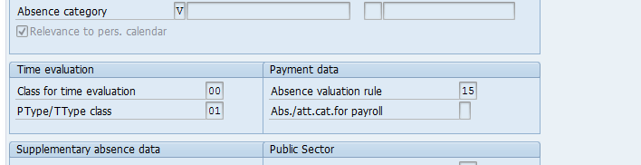

The absence valuation rules are maintained in V_T554C. A list of model entries have been provided for Vietnam (from 11-23 under PS Grouping 1) and assigned to the provided model wage types. The valuation rules should map to the correct absence in T554S:

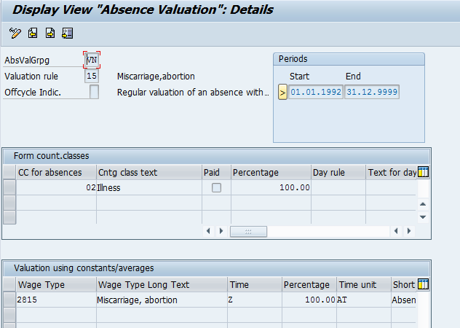

The following Model wage types where created for statutory absence valuation purposes. These wage types have the correct valuation percentages assigned (in V_T554C) as required by law. These wage types can be copied and assigned to the applicable absence types and valuation rules as used/created by customers:

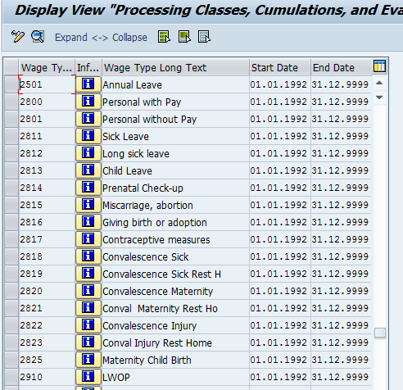

Valuation base linked to C70a wage types:

V_512W_B:

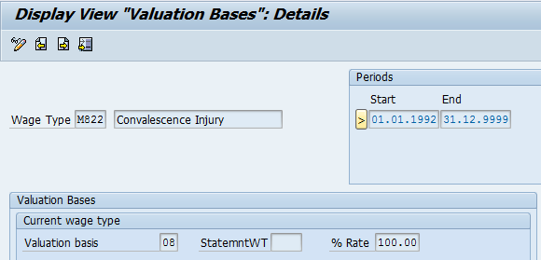

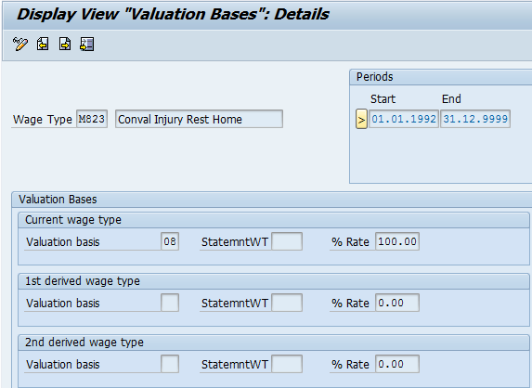

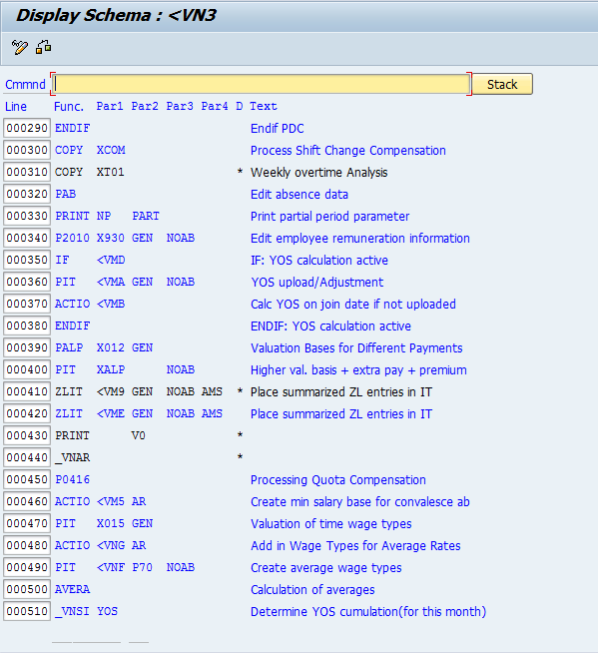

In rule <VMD constant _YOSA (T511K) is referenced to determine of YOS calculation is active.

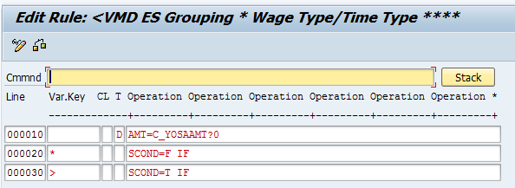

Rule <VMA Processes any YOS upload or correction values from IT2010 and adds to WT /180.

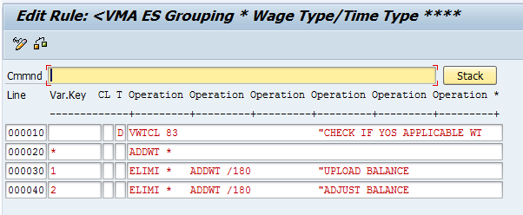

Function _VNSI:

Another entry (YOS) was added to parameter 1 in order to determine if SI contribution takes place for the EE and to add 1 month to the YOS duration. This takes place within schema –VN3 because the absences are processed before SI is processed and YOS duration is required to process the value of long service leave. (Note that YOS is still cumulated in the event of maternity leave for child birth, even though SI contribution does not take place.)

Rule <VMB checks if there any upload value or previous cumulation values for the YOS duration. If there is nothing, YOS is calculated from the Insurance Join date.

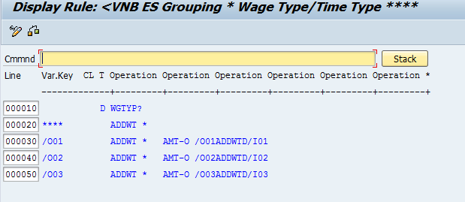

Rule <VME:

This rule determines the common minimum salary as well as the statutory

number of work days per month from T511K to calculate the base rate per

day for common minimum salary to be used in convalescence absence

calculations (Reports 66A-70A)

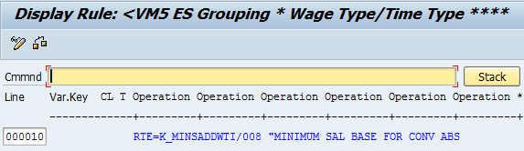

Rule <VNG:

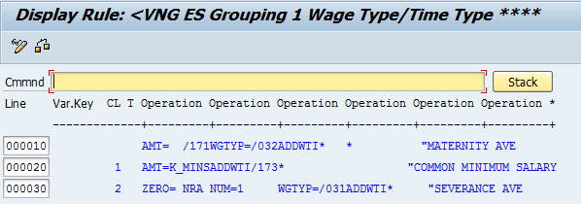

Rule <VM0 was inserted in schema –VN3 for the calculation of statutory absence values

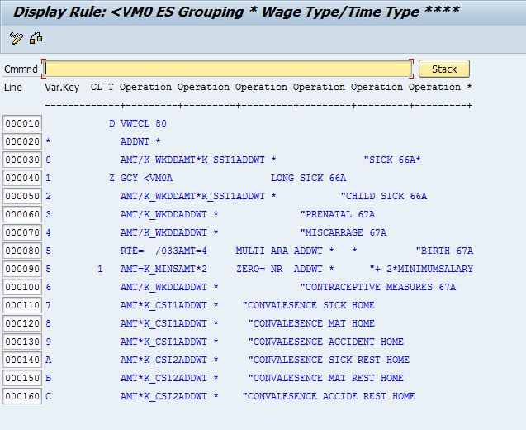

V_T511K:

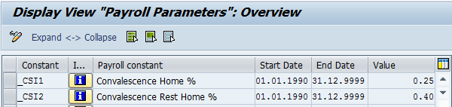

Rule <VNG Creates the average WT for Insurance salary (/032) and also creates a variable in the event of a new hire or go-live where the previous month Insurance salary is not available. The common minimum salary (/173 is also created as well as the average wage types for severance pay and maternity leave.

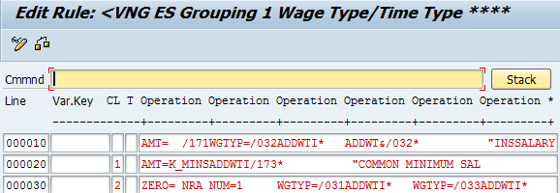

# Absence Quotas

## IMG Path & Table: Define Absence Quota Types

Path: Personnel Time Management 🡪 Time Data Recording and Administration 🡪 Managing Time Accounts Using Attendance/Absence Quotas 🡪 Time Quota Types 🡪 Define Absence Quota Types

Table: V_T556A

| ESG | PSGpg | AQTyp | Quota text | TMU | Unit | TCC | R | End Date | Start Date | Neg. deduc. |
| --- | --- | --- | --- | --- | --- | --- | --- | --- | --- | --- |
| 1 | 98 | 50 | Annual Leave | 010 | Days | 01 | 2 | 31/12/9999 | 01/01/1990 | -12.00000 |

In this step, you define the valid **absence quota types** (entitlement to time off and leave types) for your *employee subgroup and personnel subarea groupings for time quota types*.

**Example**

You want to define the entitlement to time off **time off for overtime** for your employee subgroup 1 and personnel subarea 01.

**Activities**

1. Decide which types of entitlement to time off your employees have.
2. Define the absence quota types you want to use based on the groupings. Use the SAP standard entries as a guide. If necessary, define additional absence quota types.
3. In the field Unit of Time/Measurement define whether you want the entitlement to time off to be maintained in hours or in days. Assign a time unit to the quota type.
4. If you define an absence quota type with a time unit in hours, you can enter default values for the start and end times. These are proposed in the Absence Quotas infotype when you enter absence quotas.
5. Enter the time constraint class for the absence quota type. The step ‘*Specify System Reaction to Overlapping Time Infotypes*’ contains information on the concept of defining time constraint classes.
6. In the field Negative deduction to, specify whether and to what extent there can be negative deduction of entitlement to time off.
7. In the Rounding field, specify how absences of less than one workday should be deducted from a quota which is maintained in whole days.

## IMG Path & Table: Permit Generation of Quotas in Time Evaluation

Path: Personnel Time Management 🡪 Time Data Recording and Administration 🡪 Managing Time Accounts Using Attendance/Absence Quotas 🡪 Calculating Absence Entitlements 🡪 Permit Generation of Quotas in Time Evaluation

Table: V_556A_B

| ESG | PSGpg | AQTyp | Quota text | PDC | TMU | TCC | End Date | Start Date | Neg. deduc. |
| --- | --- | --- | --- | --- | --- | --- | --- | --- | --- |
| 1 | 98 | 50 | Annual Leave |  | 010 | 01 | 31/12/9999 | 01/01/1990 | -12.00000 |

In this step, you specify that an absence quota is accrued automatically during time evaluation.

Entitlements can be accrued in the Absence Quotas infotype in one of two ways:

1. The system calculates the entitlement anew each time and overwrites the existing value in the *Absence Quotas* infotype (2006). These quota types are referred to as those that are ‘replace’.  
   Note: Absence quotas that are replaced should be processed by time evaluation once only, that is, these should be able to be updated only by function QUOTA, only by a time transfer, or only by operation UPDTQ. In any other case, the quota number cannot be determined as you require.
2. The system calculates the entitlement acquired during the current accrual period and adds this value to the existing infotype record. These quota types are referred to as those that are increased.

The quota number determined during time evaluation cannot be changed in the Absence Quotas infotype (2006). You can use the Quota Corrections infotype (2013) to correct the quota number of quotas that are increased, but not of quotas that are replaced.

**Example**

You want your employee’s leave entitlement to be determined on a monthly basis (pro rata) during time evaluation. You want the new value to be added to the existing entitlement in the Absence Quotas infotype (2006). You select the Increase field for the relevant quota type in the view.

## IMG Path & Table: Specify Rule Groups for Quota Type Selection

Path: Personnel Time Management 🡪 Time Data Recording and Administration 🡪 Managing Time Accounts Using Attendance/Absence Quotas 🡪 Calculating Absence Entitlements 🡪 Rules for Generating Absence Entitlements 🡪 Specify Rule Groups for Quota Type Selection

Feature: **QUOMO**

In this step, you determine which groupings are used to access the table for absence quota type selection when [absence quotas](SAPEVENT:DOCU_LINK/DS:GLOS.3526C5CDAFAB52B9E10000009B38F974) are generated.

Absence quota type selection is based on the employee's organizational assignment and is determined by the Quota type selection rule group.

Specific rules for quota selection can be defined using different quota type selection rule groups.

You can define the quota type selection rule group in several ways:

The [feature](SAPEVENT:DOCU_LINK/DS:GLOS.3526C22DAFAB52B9E10000009B38F974) QUOMO can be used when generating default values during recording, in report RPTQTA00, and in [time evaluation](SAPEVENT:DOCU_LINK/DS:GLOS.3526C5B5AFAB52B9E10000009B38F974) . This feature allows you to determine quota type selection rule groups depending upon a variety of employee organizational assignments. If you generate the absence quotas in time evaluation, the value from the feature is automatically queried by the system.

## IMG Path & Table: Set Base Entitlements

Path: Personnel Time Management 🡪 Time Data Recording and Administration 🡪 Managing Time Accounts Using Attendance/Absence Quotas 🡪 Calculating Absence Entitlements 🡪 Rules for Generating Absence Entitlements 🡪 Set Base Entitlements

Table: V_T559E

| ESG | PSGpg | PSGpg | AQTyp | Rule | No. | Quota text | Sen. | Sen. | TMU | Unit | Per. | End Date | Start Date | Constant |
| --- | --- | --- | --- | --- | --- | --- | --- | --- | --- | --- | --- | --- | --- | --- |
| 1 | 98 | 01 | 50 | 001 | 001 | Annual Leave | 000 | 999 | 013 | Days | 3 | 31/12/9999 | 01/01/1900 | 12.00000 |

In this step, you set rules for determining the total entitlement (base entitlement) to an absence quota type. The base entitlement forms the basis for calculating the prorated leave or absence entitlement for each accrual period.

If you determine the base entitlement according to the employee's age or seniority, you enter a constant expressed in days or hours.

If you use time evaluation to generate absence quotas , you can make the rule more specific. You may want to do this if the differentiation based on an employee's age or seniority is not sufficient for your purposes, or if you want to use other criteria to determine the base entitlement. You can do this by incorporating personnel calculation rules in the time evaluation schema . In the rules, you fill a special time type with the base entitlement according to the employee's organizational details or the results of time evaluation. You store the special time type, which the system reads in order to determine the entitlement, in this view.

If you want to vary the base entitlement according to age or seniority interval, you can distinguish between the various entitlements by numbering them sequentially.

The base entitlement is set for a specific period. You have three options for determining the base period:

**According to employee-independent periods**

The base period can relate to the calendar year, the time evaluation period, or an individually specified period in the Period Parameters table.

**According to employee-dependent periods**

You can determine the base period according to the payroll period or a period relating to a date type from the Date Specifications infotype (0041).

**Using date specifications**

Some collective agreements and company agreements stipulate that the base entitlement must be determined in relation to the period of employment. They state that, after a base period, employees must receive the exact base entitlement. To comply with this requirement, you must use a date type.

*Example:* You accrue entitlements on a daily basis. One employee joined your company on February 15, 2000, another employee on March 1, 2000. Both employees have a base entitlement of 20 days per year. After the employees have been with your company for exactly a year, the first employee's generated entitlement is slightly too high, the second employee's slightly too low, because of the leap year. The reason for this is that the following data was used as a basis for the calculation:

* In 2000, because of the leap year, 366 days for 20 days' entitlement
* In 2001, 365 days for 20 days' base entitlement

Note: The differences in the amount of entitlement calculated are only relevant for the requirements mentioned above.

**According to the accrual period**

In this case, the period over which you generate employee's quota entitlements is used as the base period (base period = accrual period).

## IMG Path & Table: Determine Validity and Deduction Periods

Path: Personnel Time Management 🡪 Time Data Recording and Administration 🡪 Managing Time Accounts Using Attendance/Absence Quotas 🡪 Calculating Absence Entitlements 🡪 Rules for Generating Absence Entitlements 🡪 Determine Validity and Deduction Periods

Table: V_T559D

| ESG | PSGpg | AQTyp | Quota text | IType | SP | TMU | IType | SP | TMU | SP | SP | TMU | RePos | RePos | RePos |
| --- | --- | --- | --- | --- | --- | --- | --- | --- | --- | --- | --- | --- | --- | --- | --- |
| 1 | 98 | 50 | Annual Leave | 4 | B |  | 4 | E | 012 | B | E | 012 | 0 | 0 | 0 |

In this step, you decide which validity and deduction periods you want to be valid for an Absence Quotas infotype record (2006) created by the system. You do this for each absence quota type.

**Deduction Period**

The deduction from and deduction to dates define the period in which the absence quota can be reduced by an absence. It need not be identical to the validity period, and can exceed it.

**Validity Period**

You only specify a validity period for absence quotas that are generated during time evaluation. Fields for entering the validity period are therefore only available for absence quotas for which you have selected replace or increase in the Permit Generation of Quotas in Time Evaluation step.

**Note:**

If you want to have the validity period determined automatically when quotas are accrued using RPTQTA00 or in the Hiring action, you should set up the validity period later in the Setting Up Methods for Quota Accrual section using the following steps:

* Set Up Automatic Accrual Using Report RPTQTA00
* Determine Default Values for Hiring

The validity period represents the period for which the time-off entitlements are filled in one infotype record. If no entitlement of this type has been generated or if the validity period has been exceeded, a new record is created.

You have a certain amount of flexibility in defining validity periods. The validity period can be:

* A fixed period such as a calendar year or the time evaluation period
* Employee-dependent period, such as the payroll period or the date type
* A period defined in the quota selection rule, such as the accrual period
* A period you have defined in Customizing, such as the period parameter

## IMG Path & Table: Determine Rules for Reducing Quota Entitlements

Path: Personnel Time Management 🡪 Time Data Recording and Administration 🡪 Managing Time Accounts Using Attendance/Absence Quotas 🡪 Calculating Absence Entitlements 🡪 Rules for Generating Absence Entitlements 🡪 Determine Rules for Reducing Quota Entitlements

Table: T559M

| RRul | Text | Rule | Rule | Rule | KDate | Refpr | Percent |
| --- | --- | --- | --- | --- | --- | --- | --- |
| 98 | Vietnam | 3 | 0 | 1 | 0 |  | 0.00 |

In this step, you specify the conditions under which you want a generated absence quota to be reduced.

You can use reduction rules to set special regulations for part-time employees. You may want to reduce the entitlement in proportion to the activity level, for example.

Days on which an employee is not active may also make it necessary to reduce the entitlement. Inactive days are usually as a result of employees joining or leaving the company. You can specify a percentage of inactive days after which you want a reduction rule to be implemented.

Certain absences such as unpaid leave can also be counted as inactive days. In this case, the reduction quotient is determined by counting the number of payroll days in relation to the accrual period.

**Example**

A part-time employee has an activity level of 50%. Accordingly, you want this employee to get 50% of the entitlement.

If less than 25% of the days within an accrual period are inactive days, you do not want the entitlement to be reduced. If more than 25% of the days are inactive, however, you want the entitlement to be reduced proportionally.

In the Percentage of inactive calendar days field, enter 25%. Under *Below percentage value*, select the No reduction field. Under *Above percentage value*, select the Proportional reduction field.

## IMG Path & Table: Determine Rules for Rounding Quota Entitlements

Path: Personnel Time Management 🡪 Time Data Recording and Administration 🡪 Managing Time Accounts Using Attendance/Absence Quotas 🡪 Calculating Absence Entitlements 🡪 Rules for Generating Absence Entitlements 🡪 Determine Rules for Rounding Quota Entitlements

Table: V_T559R

| RoRul | No. | Text | Incl. | Incl. | Roll | LLim | Upper limit | TVal |
| --- | --- | --- | --- | --- | --- | --- | --- | --- |
| 98 | 001 | Vietnam | X |  | X | 0.00500 | 0.01500 | 0.01000 |

In this step, you specify rules for rounding the quota entitlement calculated. You can use a rounding rule in the selection rule for absence quotas, for accrual entitlements, and for quota entitlements from the Absence Quotas infotype (2006).

If you use time evaluation to generate absence quotas, values with several decimal places are often the result of calculating accrual entitlements. Because these values are difficult to deduct from, you can define rules to round entitlements, for example, to the nearest whole or half number.

You set the rounding rules with reference to concrete numbers. You can specify whether:

* You only want the entitlement to be rounded within the given interval or whether the interval should be a rolling interval
* You want the specified upper and lower limits to be included in the calculation

You can specify several subrules for a rounding rule and differentiate between them by assigning sequential numbers. The system runs through the subrules in sequential order until it finds one that applies.

## IMG Path & Table: Determine Generation Rules for Quota Selection

Path: Personnel Time Management 🡪 Time Data Recording and Administration 🡪 Managing Time Accounts Using Attendance/Absence Quotas 🡪 Calculating Absence Entitlements 🡪 Rules for Generating Absence Entitlements 🡪 Define Generation Rules for Quota Selection.

Table: V_T559L

| ESG | PSGpg | PSGpg | Grp | Rule | Name of rule | AQTyp | DT | Rule | APt. | TMU | PRata | Rule | RoRul | DC | Maximum |
| --- | --- | --- | --- | --- | --- | --- | --- | --- | --- | --- | --- | --- | --- | --- | --- |
| 1 | 98 | 01 | 01 | 001 | Annual leave | 50 |  | 001 | 6 | 012 |  |  | T5 | 100 | 20.00000 |

In this step, you define rules for accruing absence entitlements for your employees.

Note: If you want to set up rules for generating absence quotas using the report RPTQTA00 or for determining default values, you can use a restricted view of the Customizing table. All non-relevant fields for this method remain hidden. The system knows which view of the Customizing table to display according to your specifications made in the Permit Online Default Values for Quotas step.

# Social Insurance (SI)

## IMG Feature: Check default values for Compulsory Social Insurance

Path: Payroll 🡪 Payroll: Vietnam 🡪 Social Insurance 🡪 Default values – Compulsory Social Insurance

Feature: -VNCI (Vietnam - Default values for Compulsory Social Insurance)

This feature determines the default values for Compulsory Social Insurance on the Social Insurances Infotype.

The return structure is X-AA-BB-CC where:

X = Contribution flag ('X' or Space)

AA = Social Insurance Type

BB = Social Insurance Fund

CC = Social Insurance Scheme.

The default settings for this feature are as follows:

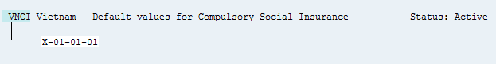

## IMG Feature: Check default values for Voluntary Social Insurance

Path: Payroll 🡪 Payroll: Vietnam 🡪 Social Insurance 🡪 Default values – Voluntary Social Insurance

Feature: -VNVI (Vietnam - Default values for Voluntary Social Insurance)

This feature determines the default values for Voluntary Social Insurance on the Social Insurances Infotype.

The return structure is X-AA-BB-CC where:

X = Contribution flag ('X' or Space)

AA = Social Insurance Type

BB = Social Insurance Fund

CC = Social Insurance Scheme.

The default settings for this feature are as follows:



## IMG Feature: Check default values for Unemployment Insurance

Path: Payroll 🡪 Payroll: Vietnam 🡪 Social Insurance 🡪 Default values – Unemployment Insurance

Feature: -VNUI (Vietnam - Default values for Unemployment Insurance)

This feature determines the default values for Unemployment Insurance on the Social Insurances Infotype.

The return structure is X-AA-BB-CC where:

X = Contribution flag ('X' or Space)

AA = Social Insurance Type

BB = Social Insurance Fund

CC = Social Insurance Scheme.

The default settings for this feature are as follows:

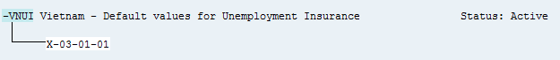

## IMG Feature: Check default values for Health Insurance

Path: Payroll 🡪 Payroll: Vietnam 🡪 Social Insurance 🡪 Default values – Health Insurance

Feature: -VNHI (Vietnam - Default values for Health Insurance)

This feature determines the default values for Health Insurance on the Social Insurances Infotype.

The return structure is X-AA-BB-CC where:

X = Contribution flag ('X' or Space)

AA = Social Insurance Type

BB = Social Insurance Fund

CC = Social Insurance Scheme.

The default settings for this feature are as follows:

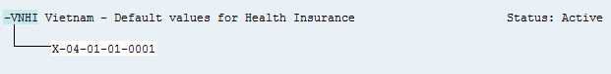

## IMG Path & Table: Define Province Codes

Path: Payroll 🡪 Payroll: Vietnam 🡪 Social Insurance 🡪 Define Province Codes

Table: /EPIUSE/V_T7VN61

| Code | Province Text |
| --- | --- |
| 1 | Thành phố Hà Nội |
| 2 | Hà Giang |
| 4 | Cao Bằng |
| 6 | Bắc Kạn |
| 8 | Tuyên Quang |
| 10 | Lào Cai |
| 11 | Điện Biên |
| 12 | Lai Châu |
| 14 | Sơn La |
| 15 | Yên Bái |
| 17 | Hòa Bình |
| 19 | Thái Nguyên |
| 20 | Lạng Sơn |
| 22 | Quảng Ninh |
| 24 | Bắc Giang |
| 25 | Phú Thọ |
| 26 | Vĩnh Phúc |
| 27 | Bắc Ninh |
| 30 | Hải Dương |
| 31 | Thành phố Hải Phòng |
| 33 | Hưng Yên |
| 34 | Thái Bình |
| 35 | Hà Nam |
| 36 | Nam Định |
| 37 | Ninh Bình |
| 38 | Thanh Hóa |
| 40 | Nghệ An |
| 42 | Hà Tĩnh |
| 44 | Quảng Bình |
| 45 | Quảng Trị |
| 46 | Thừa Thiên - Huế |
| 48 | Thành phố Đã Nẵng |
| 49 | Quảng Nam |
| 51 | Quảng Ngãi |
| 52 | Bình Định |
| 54 | Phú Yên |
| 56 | Khánh Hòa |
| 58 | Ninh Thuận |
| 60 | Bình Thuận |
| 62 | Kon Tum |
| 64 | Gia Lai |
| 66 | Đăk Lăk |
| 67 | Đăk Nông |
| 68 | Lâm Đồng |
| 70 | Bình Phước |
| 72 | Tây Ninh |
| 74 | Bình Dương |
| 75 | Đồng Nai |
| 77 | Bà Rịa - Vũng Tàu |
| 79 | TP. Hồ Chí Minh |
| 80 | Long An |
| 82 | Tiền Giang |
| 83 | Bến Tre |
| 84 | Trà Vinh |
| 86 | Vĩnh Long |
| 87 | Đồng Tháp |
| 89 | An Giang |
| 91 | Kiên Giang |
| 92 | Thành phố Cần Thơ |
| 93 | Hậu Giang |
| 94 | Sóc Trăng |
| 95 | Bạc Liêu |
| 96 | Cà Mau |

In this step, you define province Code for Social Insurance Purposes.

**Changes are not recommended**

## IMG Path & Table: Define Hospital Codes

Path: Payroll 🡪 Payroll: Vietnam 🡪 Social Insurance 🡪 Define Hospital Codes

Table: /EPIUSE/V_T7VN60

In this step, you define Hospital Codes for Social Insurance purposes and Hospital Codes are assigned to Provinces.

**Changes are not recommended**

## IMG Path & Table: Define Social Insurance Types

Path: Payroll 🡪 Payroll: Vietnam 🡪 Social Insurance 🡪 Social Insurance types

Table: /EPIUSE/V_T7VN20

| Insurance Type | Insurance text | Insurance Reference no |
| --- | --- | --- |
| 01 | Compulsory Social Insurance |  |
| 02 | Voluntary Social Insurance |  |
| 03 | Unemployment Insurance |  |
| 04 | Health Insurance |  |

In this step, you defines different Social Insurance Types.

The default values are:

* 01 = Compulsory Social Insurance
* 02 = Voluntary Social Insurance
* 03 = Unemployment Insurance
* 04 = Health Insurance

**Changes other than that of the description are not recommended**

## IMG Path & Table: Define Social Insurance Funds

Path: Payroll 🡪 Payroll: Vietnam 🡪 Social Insurance 🡪 Social Insurance Funds

Table: /EPIUSE/V_T7VN21

| Insurance Type | Insurance Fund | Insurance text |
| --- | --- | --- |
| 01 | 01 | Compulsory Social Insurance |
| 02 | 01 | Voluntary Social Insurance |
| 03 | 01 | Unemployment Insurance |
| 04 | 01 | Health Insurance |

In this step, you defines different Social Insurance Funds.

Each fund must be related to a Social Insurance Type. Multiple funds are allowed per Social Insurance Type. You can maintain the Fund description in this table.

## IMG Path & Table: Define Social Insurance Schemes

Path: Payroll 🡪 Payroll: Vietnam 🡪 Social Insurance 🡪 Social Insurance Schemes

Table: /EPIUSE/V_T7VN22

| Ins Type | Ins Fund | Ins Scheme | Text | RefNo | Max EE Con | Max ER Con | Applic. Earn WT | ERCon WT | EE Con WT | TotCon WT | Curr | Calc. Ind |
| --- | --- | --- | --- | --- | --- | --- | --- | --- | --- | --- | --- | --- |
| 01 | 01 | 01 | Compulsory Social Insurance |  | 10** | 10** | /102 | /321 | /320 | /325 | VND | P |
| 02 | 01 | 01 | Voluntary Social Insurance |  | 10** | 10** | /103 | /331 | /330 | /335 | VND | P |
| 03 | 01 | 01 | Unemployment Insurance |  | 10** | 10** | /104 | /341 | /340 | /345 | VND | P |
| 04 | 01 | 01 | Health Insurance |  | 10** | 10** | /105 | /351 | /350 | /355 | VND | P |

In this step, you defines different Social Insurance Funds.

Each fund must be related to a Social Insurance Type. Multiple funds are allowed per Social Insurance Type. You can maintain the Fund description in this table**.**

**Changes other than that of the description are not recommended**

## IMG Path & Table: Define Social Insurance Categories

Path: Payroll 🡪 Payroll: Vietnam 🡪 Social Insurance 🡪 Social Insurance Categories

Table: /EPIUSE/V_T7VN23

| Insurance Type | Insurance Fund | Insurance Scheme | Category Text | Category Text |
| --- | --- | --- | --- | --- |
| 04 | 01 | 01 | 0001 | Compulsory Social Insurance |

In this step, you defines different Social Insurance Categories. Social Insurance Categories are usually only used for Health Insurances to refine schemes further.

## IMG Path & Table: Define Social Insurance Contributions

Path: Payroll 🡪 Payroll: Vietnam 🡪 Social Insurance 🡪 Social Insurance Contributions

Table: /EPIUSE/V_T7VN24

| Insurance Scheme | Insurance Category | Bracket | End Date | Start Date |
| --- | --- | --- | --- | --- |
|  |  |  |  |  |

In this step, defines different Social Insurance Contributions. This table will usually contain lookup amounts - percentages should be configured in the SI ER/EE split table. The lower bound should contain the starting value of a bracket. The member contribution contains the value in case of an amount lookup. Health Insurances can specify additional dependent contributions.

## IMG Path & Table: Define Social Insurance ER/EE Splits

Path: Payroll 🡪 Payroll: Vietnam 🡪 Social Insurance 🡪 Social Insurance Contributions

Table: /EPIUSE/V_T7VN25

| Insurance Type | Insurance Fund | Insurance Scheme | Bracket | Lower Bound Lookup | Amount or Percentage | Employer Contrib | Employee Contrib. | Currency |
| --- | --- | --- | --- | --- | --- | --- | --- | --- |
| 01 | 01 | 01 | 1 |  | P | 16.00 | 6.00 | VND |
| 02 | 01 | 01 | 1 |  | P | 0 | 0 | VND |
| 03 | 01 | 01 | 1 |  | P | 1.00 | 1.00 | VND |
| 04 | 01 | 01 | 1 |  | P | 3.00 | 1.50 | VND |

In this step, defines the Employer / Employee percentages used to calculated contributions based on applicable earnings. This table can also be used to split Employer / Employee contributions that are based on amounts.

## SI calculation amendment on employees less than 14 working days

Employees in Vietnam should pay contributions towards Social Insurances.

However there is an exception to this rule as described in article 85.3 of the Social Insurance Law No: 58/2014/QH13.

According to this stipulation:

*Employees who neither work nor receive salary for 14 working days or more in a month are not required to pay social insurance premiums in that month. This period shall not be counted for enjoyment of social insurance regimes, except cases of maternity leave.*

The current solution however applies this rule based on a Work percentage principle.

SI is calculated only when an employee is active on the 15th and worked more than 50% of working days.

The work percentage is calculated as ((number of days worked – unpaid days) / number of days worked).

This may result in an employee being only absent for 13 days but the work-percentage is less than 50% so no SI is calculated.

* Payroll function _VNSI was updated to allow for the checking of unpaid absence days based on parameter 3
  + Options for parameter 3:
    - P – work percentage (If less than 50% no SI calculation)
    - D – Unpaid absence days count (14 days or more , no SI calculation)
    - A – SI will be calculated regardless (no checks for P or D done)
  + Log printing was also updated to show more information in the payroll log.
* Schema -VN7 was updated to update parameter 3

The default solution will still use the work percentage check.

The standard schema -VN7 is now configured as depicted in the image below:

The value ‘P’ replaces the previous value of ‘15’.

The P now indicates the ‘Percentage’ option.

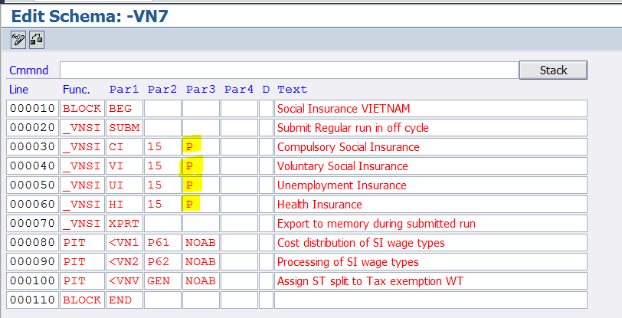

If the client wants to change this work-percentage check to a check based on the 14-day rule, this schema (or customer version) should look as follows:

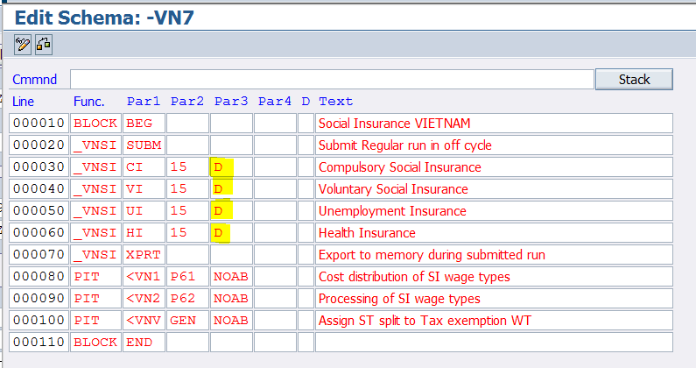

Alternatively if neither of these checks are valid the option ‘A’ can be used.

**NB: If schema -VN7 was replaced by a customer version it HAS TO be updated as the previous value ‘15’ will not work and it will result in a schema generation error.**

In such a scenario, replace the 15 in parameter 3 by either ‘P’ or ‘D’ and if you used a blank before for parameter 3, replace it with an ‘A’.

In function _VNSI each function, it calculates the active days of the employee to determine Unpaid leave for calculate SI contribution.

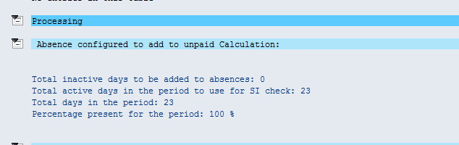

Payroll log will show more detail information:

For option ‘P’, work-percentage is checked:

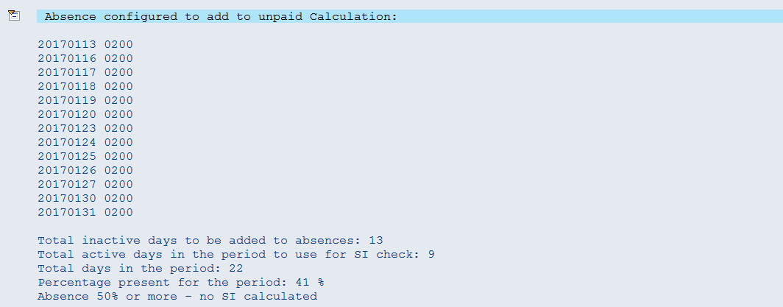

For option ‘D’ number of absence days are checked:

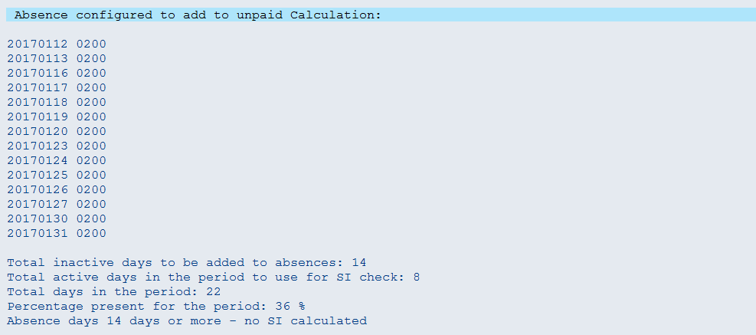

# Tax

## IMG Path & Feature: Default values – Tax Infotype

Path: Payroll 🡪 Payroll: Vietnam 🡪 Personal Income Tax 🡪 Default values – Income Tax

Feature: -VNTX (Vietnam - Default values for Personal Income Tax)

This feature determines the default values for the Personal Income Tax Infotype. The return structure is XX-YY-ZZ where:

* XX = Nature of Person
* YY = Nationality
* ZZ = Employment Category.

## IMG Path & Table: Nature of Person

Path: Payroll 🡪 Payroll: Vietnam 🡪 Personal Income Tax 🡪 Nature of Person

Table: /EPIUSE/V_T7VN01

| Nature | Nature Txt |
| --- | --- |
| 01 | Resident |
| 02 | Non-resident |

In this step, this table defines different types of persons for taxation purposes. The default configuration is:

* 01 = Resident
* 02 = Non-resident

## IMG Path & Table: Nationality

Path: Payroll 🡪 Payroll: Vietnam 🡪 Personal Income Tax 🡪 Nationality

Table: /EPIUSE/V_T7VN02

| Nationality | Nationality |
| --- | --- |
| 01 | Vietnamese |
| 02 | Foreigner |

In this step, this table defines different types of nationality for taxation purposes. The default configuration is:

* 01 = Vietnamese
* 02 = Foreigner

From 2009 onwards the tax rates for Vietnamese and Foreigners are identical. The recommendation is to keep this table as is for backward compatibility

## IMG Path & Table: Employment Category

Path: Payroll 🡪 Payroll: Vietnam 🡪 Personal Income Tax 🡪 Employment Category

Table: /EPIUSE/V_T7VN03

| Emp. Cat. | Employment Category |
| --- | --- |
| 01 | Full-time |
| 02 | Temporary |
| 03 | Probation |

In this step, this table defines different employment types for taxation purposes. The default configuration is:

* 01 = Full-time
* 02 = Temporary
* 03 = Probation

**Changes to this table are not recommended.**

## IMG Path & Table: Tax Offices / Regions

Path: Payroll 🡪 Payroll: Vietnam 🡪 Personal Income Tax 🡪 Tax Offices / Regions

Table: /EPIUSE/V_T7VN04

| Emp. Cat. | Employment Category |
| --- | --- |
| 01 | Ha Noi |
| 02 | Hai Phong |
| 03 | Da Nang |
| 04 | Ho Chi Minh |
| 05 | Can Tho |
| 06 | Dong Nai |

In this step, this table defines different locations for tax reporting purposes.

It is used as a lookup table in the Personal Income Tax infotype.

Do not remove entries linked to Master Data.

## IMG Path & Table: Tax Exempt Reasons

Path: Payroll 🡪 Payroll: Vietnam 🡪 Personal Income Tax 🡪 Tax Exempt Reasons

Table: /EPIUSE/V_T7VN05

| Emp. Cat. | Employment Category |
| --- | --- |
| 01 | No Reason |

In this step, this table definess reasons for individuals not paying tax.

The default configuration does not contain any reasons.

## IMG Path & Table: Tax Rates

Path: Payroll 🡪 Payroll: Vietnam 🡪 Personal Income Tax 🡪 Tax Rates

Table: /EPIUSE/V_T7VN10

| Nat. Pers | Nat. | Emp. Cat. | Start date | End Date | Bracket | From Income Month | From Income Year | Tax on income month | Tax on income year | Tax rate (%) | Curr. |
| --- | --- | --- | --- | --- | --- | --- | --- | --- | --- | --- | --- |
| 01 | 01 | 01 | 01.01.2009 | 31.12.9999 | 1 | 0 | 0 | 0 | 0 | 5.00 | VND |
| 01 | 01 | 01 | 01.01.2009 | 31.12.9999 | 2 | 5,000,000 | 60,000,000 | 250,000 | 3,000,000 | 10.00 | VND |
| 01 | 01 | 01 | 01.01.2009 | 31.12.9999 | 3 | 10,000,000 | 120,000,000 | 750,000 | 9,000,000 | 15.00 | VND |
| 01 | 01 | 01 | 01.01.2009 | 31.12.9999 | 4 | 18,000,000 | 216,000,000 | 1,950,000 | 23,400,000 | 20.00 | VND |
| 01 | 01 | 01 | 01.01.2009 | 31.12.9999 | 5 | 32,000,000 | 384,000,000 | 4,750,000 | 57,000,000 | 25.00 | VND |
| 01 | 01 | 01 | 01.01.2009 | 31.12.9999 | 6 | 52,000,000 | 624,000,000 | 9,750,000 | 117,000,000 | 30.00 | VND |
| 01 | 01 | 01 | 01.01.2009 | 31.12.9999 | 7 | 80,000,000 | 960,000,000 | 18,150,000 | 217,800,000 | 35.00 | VND |
| 01 | 02 | 01 | 01.01.2009 | 31.12.9999 | 1 | 0 | 0 | 0 | 0 | 5.00 | VND |
| 01 | 02 | 01 | 01.01.2009 | 31.12.9999 | 2 | 5,000,000 | 60,000,000 | 250,000 | 3,000,000 | 10.00 | VND |
| 01 | 02 | 01 | 01.01.2009 | 31.12.9999 | 3 | 10,000,000 | 120,000,000 | 750,000 | 9,000,000 | 15.00 | VND |
| 01 | 02 | 01 | 01.01.2009 | 31.12.9999 | 4 | 18,000,000 | 216,000,000 | 1,950,000 | 23,400,000 | 20.00 | VND |
| 01 | 02 | 01 | 01.01.2009 | 31.12.9999 | 5 | 32,000,000 | 384,000,000 | 4,750,000 | 57,000,000 | 25.00 | VND |
| 01 | 02 | 01 | 01.01.2009 | 31.12.9999 | 6 | 52,000,000 | 624,000,000 | 9,750,000 | 117,000,000 | 30.00 | VND |
| 01 | 02 | 01 | 01.01.2009 | 31.12.9999 | 7 | 80,000,000 | 960,000,000 | 18,150,000 | 217,800,000 | 35.00 | VND |
| 01 | 01 | 02 | 19.09.2011 | 31.12.9999 | 2 | 1,000,000 | 12,000,000 | 100,000 | 1,200,000 | 10.00 | VND |
| 01 | 01 | 03 | 01.01.2008 | 31.12.9999 | 1 | 0 | 0 | 0 | 0 | 10.00 | VND |
| 02 | 01 | 01 | 01.01.2008 | 31.12.9999 |  |  |  |  |  |  | VND |
| 02 | 02 | 01 | 01.01.2009 | 31.12.9999 | 1 | 0 | 0 | 0 | 0 | 20.00 | VND |
| 02 | 02 | 02 | 01.01.2009 | 31.12.9999 |  |  |  |  |  |  | VND |
| 02 | 02 | 03 | 01.01.2009 | 31.12.9999 | 1 | 0 | 0 | 0 | 0 | 10.00 | VND |

In this step, this table defines the personal income tax calculation tables.

There are different entries per Nature of Person, Nationality and Employment Category. Both monthly and annual values should be filled in.

**Changes to this table are not recommended, changes should be applied by support packs.**

## IMG Path & Table: Tax Deductions

Path: Payroll 🡪 Payroll: Vietnam 🡪 Personal Income Tax 🡪 Tax Deductions

Table: /EPIUSE/V_T7VN11

| Nat. Pers | Nat. | Emp. Cat. | Start date | End Date | Tax Ded Month | Tax Ded Year | Depend Ded Month | Depend Ded year | Curr. |
| --- | --- | --- | --- | --- | --- | --- | --- | --- | --- |
| 01 | 01 | 01 | 01.01.2008 | 31.12.9999 | 4,000,000 | 48,000,000 | 1,600,000 | 19,200,000 | VND |
| 01 | 01 | 02 | 01.01.2008 | 31.12.9999 | 0 | 0 | 0 | 0 | VND |
| 01 | 01 | 03 | 01.01.2008 | 31.12.9999 | 0 | 0 | 0 | 0 | VND |
| 01 | 02 | 01 | 01.01.2008 | 31.12.9999 | 4,000,000 | 48,000,000 | 1,600,000 | 19,200,000 | VND |
| 01 | 02 | 02 | 01.01.2008 | 31.12.9999 | 0 | 0 | 0 | 0 | VND |
| 01 | 02 | 03 | 01.01.2008 | 31.12.9999 | 0 | 0 | 0 | 0 | VND |
| 02 | 02 | 02 | 01.01.2009 | 31.12.9999 | 0 | 0 | 0 | 0 | VND |
| 02 | 02 | 03 | 01.01.2009 | 31.12.9999 | 0 | 0 | 0 | 0 | VND |

In this step, this table defines the personal income tax deductions.

There are different entries per Nature of Person, Nationality and Employment Category. The first value is the tax deduction per individual. The second value is the tax deduction per dependent. Both monthly and annual values should be filled in.

**Changes to this table are not recommended, changes should be applied by support pacs.**

## IMG Table & Feature: Tax Finalisation

Table: /EPIUSE/V_T7VN30

Table is to identify the tax finalization period for the schema to process

The period parameter for the payroll area for finalization should be entered together the in-period for finalization together with the for-period (where finalization should be calculated)

| Per Pa | Finalise For Per Yr | Finalise For Period | Finalise InPer Yr | Finalise In Period |
| --- | --- | --- | --- | --- |
| 44 | 2015 | 12 | 2015 | 12 |
| 44 | 2016 | 12 | 2017 | 1 |

The following checks were built in to check whether finalisation should take place:

Finalization will not take place under the following circumstances:

An entry has been created in table /epiuse/v_t7vn30 for the applicable period parameter and the in- and for period(s) to finalize for the applicable tax year.

To allow employee tax finalization during the year

Feature –VNFP

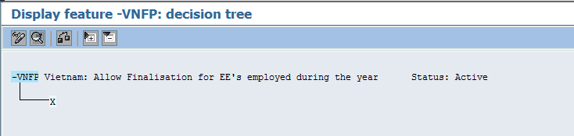

# Severance Pay

## *IMG Path & Feature: Severance Pay Date Type*

Path: Payroll 🡪 Payroll: Vietnam 🡪 Dates 🡪 Severance Pay Date Type

**Feature: -VNEN** Vietnam: IT0041 subtype for Severance Pay

This feature is used to specify the Infotype 0041 date type that should be used for Severance Pay cut off

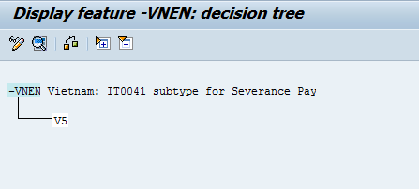

Processing class 70 needs to be assigned to any wagetypes which are to be included in the severance pay calculation.

**PCR : <VNK**

The rule gets the average calculated by function AVERA in wage type /030. Then operation _VNEN returns the number of complete months between the employee’s entry date and termination date. The rule then divides the number of months by 12 to get the number of year. The value is then rounded up to the nearest “half” year or 6 months. The rule then applies the minimum and maximum number of years. This adjusted number of years is then multi plied by the severance applicable earnings. The resulting amount is then multiplied by the percentage factor based on the processing class 70 value (100% vs. 50%).

# Gross up

## *Wage types, Table & Schema: Severance Pay Date Type*

Define template grossup wage types

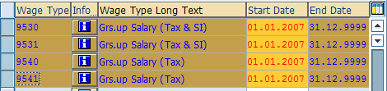

9530 is use for Salary grossup Tax (WT /260) and SI contribution (WT/111)

9531 is use for Additional payment grossup Tax (WT /260) and SI contribution (WT/111)

9540 is use for Salary grossup Tax (WT /260)

9541 is use for Additional payment grossup Tax (WT /260)

Table V_T541N

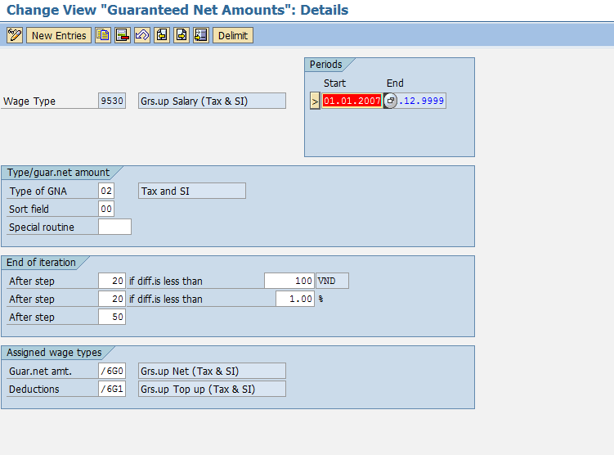

Type of GNA:

01 – Grossup tax on tax only

02 – Grossup tax on tax and SI

Guar. Net amt: Wage type based on Tax gross up amount

Deduction: Grossup tax calculate amount

Table V_T541A

Rule 01 is grossup up on tax amount WT/260

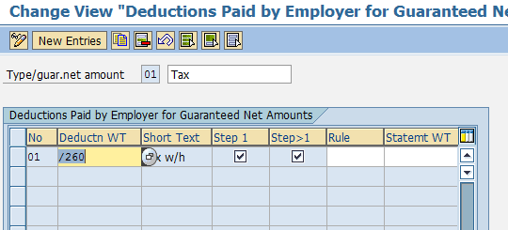

Rule 02 is grossup up on tax amount WT/260 and SI contribution WT/111

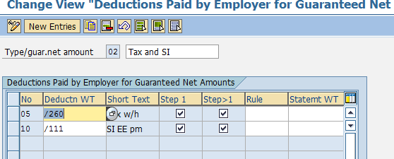

Rule -VN6

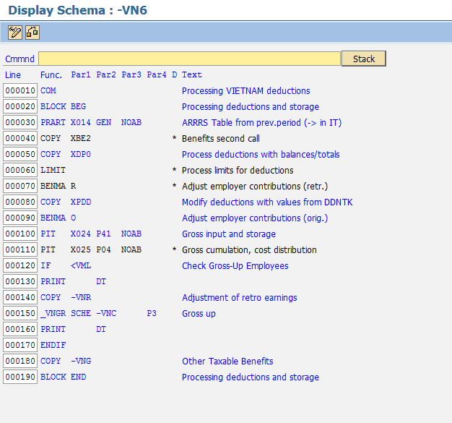

New Rule <VML

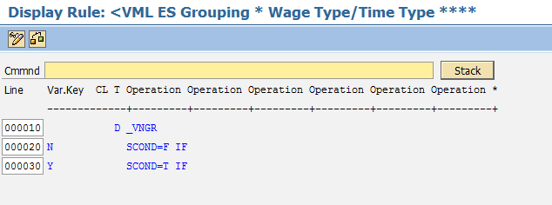

Rule <VNR

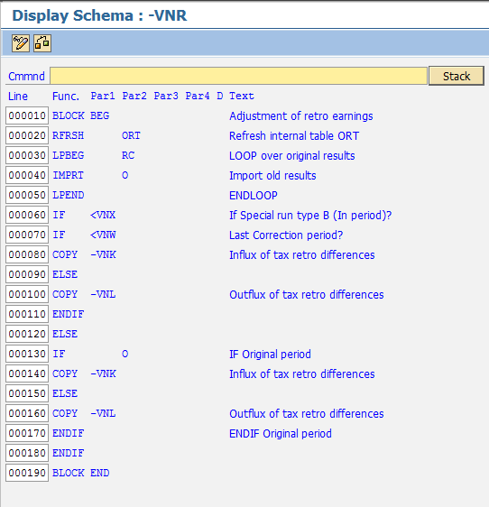

New Rule -VNL

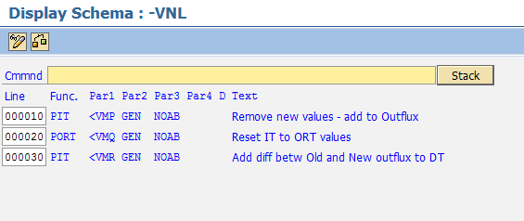

New Rule <VMP

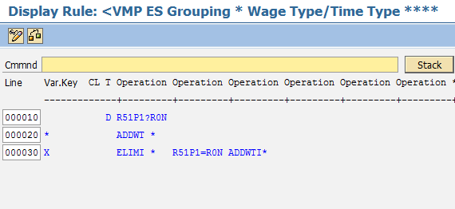

New Rule <VMQ

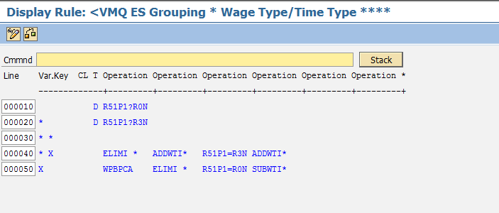

New Rule <VMR

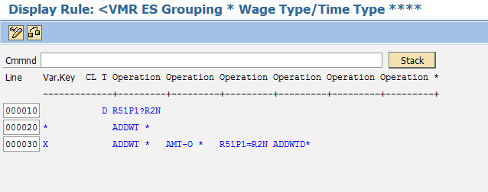

New Subema -VNK

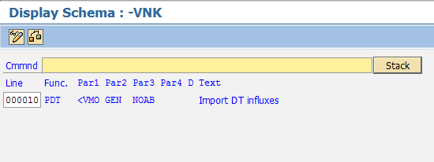

New Payroll Rule <VMO

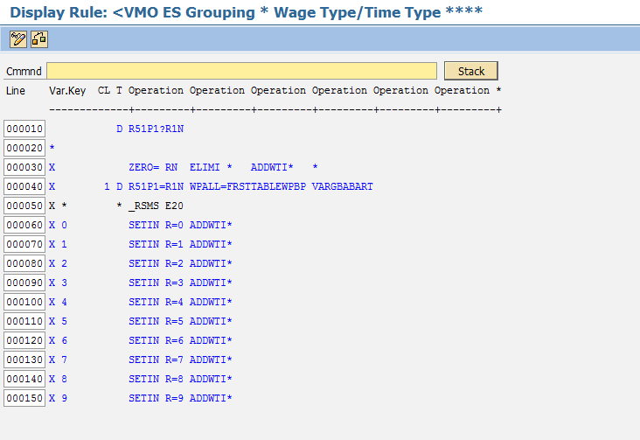

Update Schema -VNC

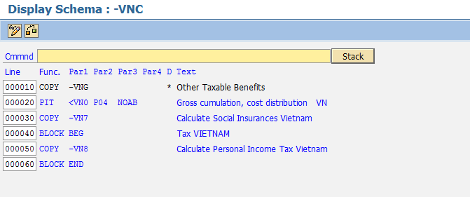

Update Schema –VN8

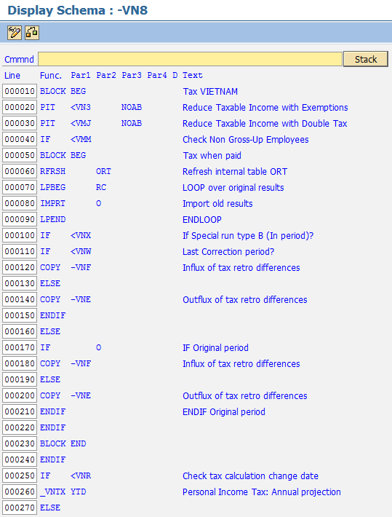

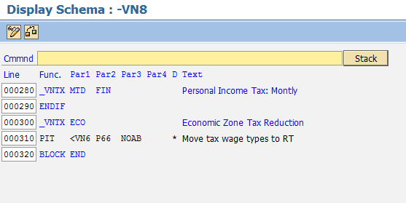

New Rule <VMM

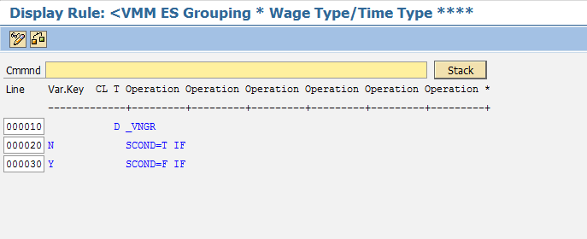

Update -VNF

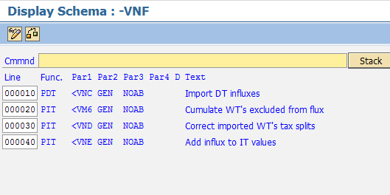

Update Schema -VNJ

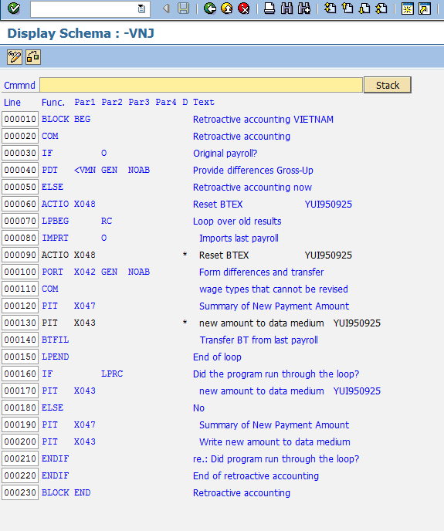

New rule <VMN

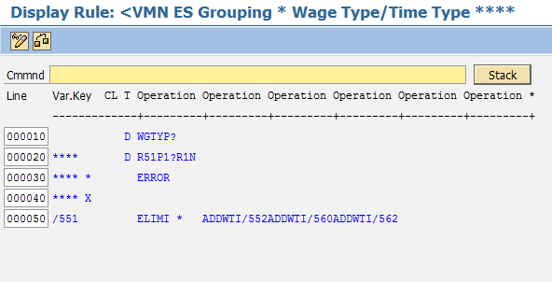

* New feature -VNGR
  + The purpose of this feature is to identify gross-up employees
    - Gross-up employees should have return value ‘Y’
    - Non gross-up employees should have return value ‘N’
    - The selection of gross-up employees can be based on the following fields:

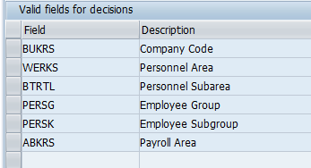

Personnel subarea = -VN1

Feature:

In this example gross-up employees are identified by Personnel subarea –VN2

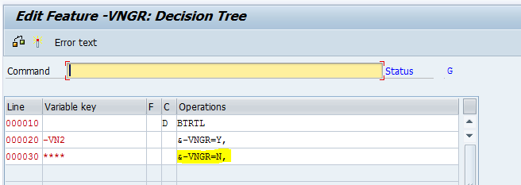

Rule <VMM

Notice the payroll operation will return value T, so the rule will continue (not move to ELSE/ENDIF part)

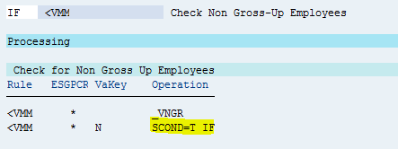

Payroll results for retro-active run:

Influx wage types created in current period:

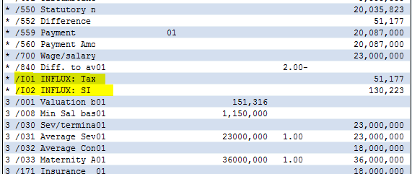

Example gross-up employee:

Personnel subarea = -VN2

Feature:

In this example gross-up employees are identified by Personnel subarea –VN2

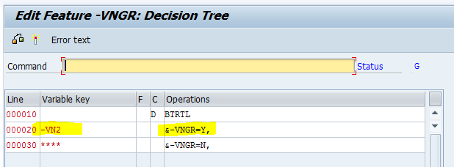

Rule <VML

Notice the payroll operation will return value T, so the rule will continue (not move to ELSE part)

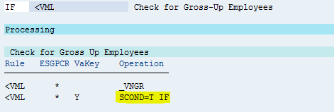

Rule <VMM

Notice the payroll operation will return value F, so the rule will move to ELSE/ENDIF part

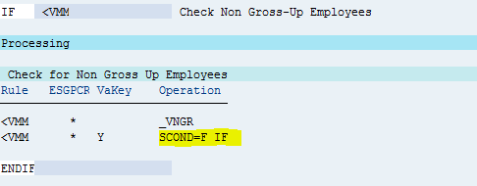

Payroll results for retro-active run:

Influx wage types created in current period:

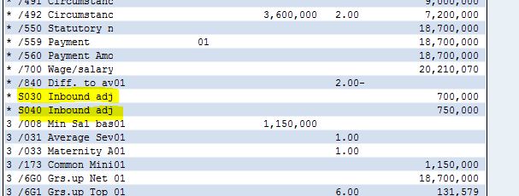

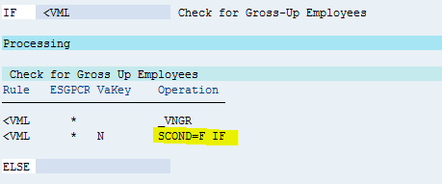

* New operation _VNGR
  + This function is used to read feature –VNGR to determine gross-up employees
* New payroll rule <VML (check for gross-up employees)
  + A True or False statement will be returned in the rule
    - Gross-up employees = True
    - Non gross-up employees – False
* New payroll rule <VMM (check for non gross-up employees)
  + A True or False statement will be returned in the rule
    - Gross-up employees = False
    - Non gross-up employees – True
* New payroll rules <VMN,<VMO, <VMP, <VMQ, <VMR
  + These rules handle the new flux solution for gross-up employees
* New flux wage types:
  + R030 - Outbound adjustment: M030
  + R040 - Outbound adjustment: M040
  + S030 - Inbound adjustment: M030
  + S040 - Inbound adjustment: M040
* Table V_T51P1
  + New indicators R0, R1, R2 and R3

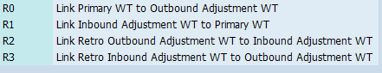

* + Linking of gross-up wage types to outbound flux wage types – R0
    - 
  + Linking of gross-up wage types to inbound flux wage types – R1
    - 
  + Linking of Outbound wage types to inbound wage types – R2
    - 
  + Linking of inbound wage types to outbound wage types – R3

To process Grossup in the system

Enter Grossup wages type amount in IT0014

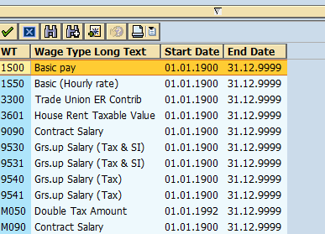

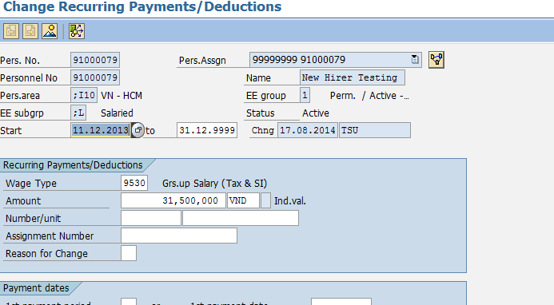

Run Payroll

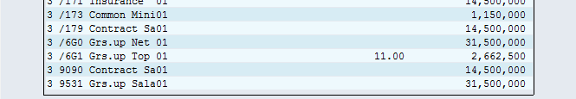

/6G0, /6G2 – Grossup up based amount

/6G1, /6G3 – Grossup up tax calculate amount

The amount is printing on Earning box on payslip.

Taxable amount /106 included /6G0, /6G1, /6G2 and /6G3.

Final taxable include grossup tax cumulate in WT/260

Feature –VNGR to read IT9520 “Gross Up indicator”

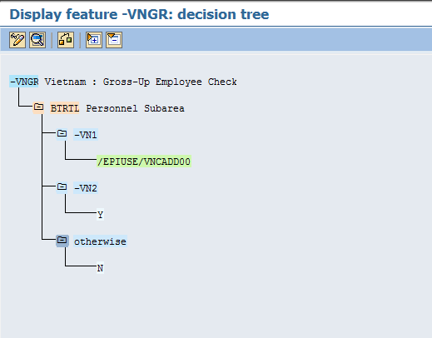

New field IT9520 “Gross Up Indicator” to identify the grossup employee

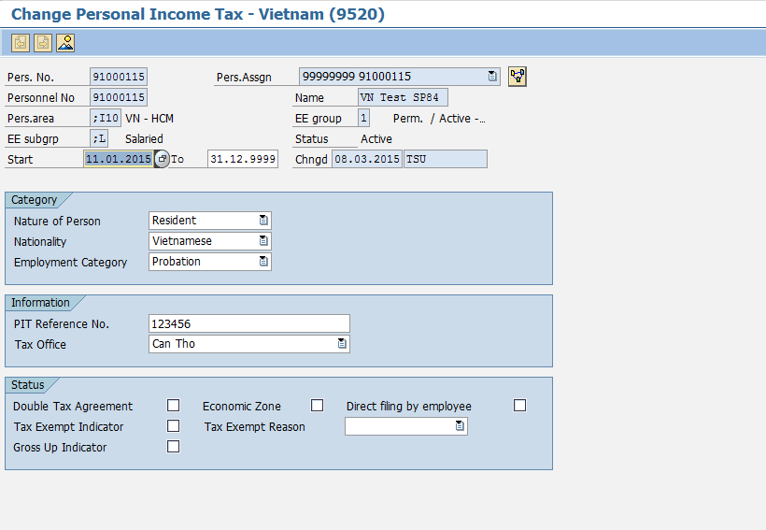

# Reporting

## IMG Table: Tax Deductions

Table: /EPIUSE/V_T7VN50

Employer details use to print on reporting

| ER info type | Employer Information type (Text) |
| --- | --- |
| 1 | Company Name (Tên người nộp thuế) |
| 2 | Address Line 1 |
| 3 | Management Agency |
| 4 | Economic Sectors |
| 5 | Unit Code |
| 6 | KCB Code (Tỉnh/thành phố (Province/ City |
| 7 | Mã số thuế (Tax code) |
| 8 | Economic sectors |
| 9 | Quận/huyện (District) |
| 10 | Điện thoại (Phone Number) |
| 11 | Fax |
| 12 | Email |
| 13 | Tên đại lý thuế (nếu có)/Tax agent name |
| 14 | Mã số thuế (Tax code) |
| 15 | Địa chỉ (Address): |
| 16 | Quận/huyện (District |
| 17 | Tỉnh/thành phố (Province/ City) |
| 18 | Điện thoại (Phone Number) |
| 19 | Fax |
| 20 | Email |
| 21 | Hợp đồng đại lý thuế: Số/contract number |
| 22 | Ngày / Contract date |
| 23 | Company SI Code |
| 24 | Address Line 2 |
| 25 | Postal code |
| 26 | City |

Table: /EPIUSE/V_T7VN51

| ER Key | ER info type | Employer detail text | Employer Information type (Text) |
| --- | --- | --- | --- |
| 1 | 1 | 1234567890abcdefghigjklmnopqrstwuyz12 | Company Name (Tên người nộp thuế) |
| 1 | 2 | Address line 1 | Address Line 1 |
| 1 | 3 | Management Agency | Management Agency |
| 1 | 4 | Economic sectors | Economic Sectors |
| 1 | 5 | Unit Code | Unit Code |
| 1 | 6 | KCB Code (Tỉnh/thành phố (Province/ C | KCB Code (Tỉnh/thành phố (Province/ City |
| 1 | 7 | Mã số thuế (Tax code) | Mã số thuế (Tax code) |
| 1 | 8 | Quận/huyện (District) | Economic sectors |
| 1 | 9 | Điện thoại (Phone Number) | Quận/huyện (District) |
| 1 | 10 | Fax | Điện thoại (Phone Number) |
| 1 | 11 | Email | Fax |
| 1 | 12 | Tên đại lý thuế (nếu có)/Tax agent name | Email |
| 1 | 13 | Mã số thuế (Tax code) | Tên đại lý thuế (nếu có)/Tax agent name |
| 1 | 14 | Địa chỉ (Address) | Mã số thuế (Tax code) |
| 1 | 15 | Quận/huyện (District | Địa chỉ (Address): |
| 1 | 16 | Tỉnh/thành phố (Province/ City) | Quận/huyện (District |
| 1 | 17 | Điện thoại (Phone Number) | Tỉnh/thành phố (Province/ City) |
| 1 | 18 | Fax | Điện thoại (Phone Number) |
| 1 | 19 | Email | Fax |
| 1 | 20 | Hợp đồng đại lý thuế: Số/contract number | Email |
| 1 | 21 | Quận/huyện (District) | Hợp đồng đại lý thuế: Số/contract number |
| 1 | 22 | Ngày / Contract date | Ngày / Contract date |
| 1 | 23 | Mã đơn vị / Company SI Code | Company SI Code |
| 1 | 24 | Address line 2 | Address Line 2 |
| 1 | 25 | Postal code | Postal code |
| 1 | 26 | City | City |

Table: /EPIUSE/V_T7VN60

Hospital Codes use in IT9521

| Province | Hosp Code | Province Text | Employer Information type (Text) |
| --- | --- | --- | --- |
| 1 | 3 | Thành phố Hà Nội | Bệnh viện đa khoa Xanh Pôn |
| 1 | 4 | Thành phố Hà Nội | Bệnh viện đa khoa Đống Đa |
| 1 | 5 | Thành phố Hà Nội | Bệnh viện Việt Nam-Cu Ba |
| 1 | 6 | Thành phố Hà Nội | Bệnh viện Thanh Nhàn |
| 1 | 7 | Thành phố Hà Nội | Bệnh viện E |
| 1 | 12 | Thành phố Hà Nội | PKĐK khu vực Đông Mĩ |
| 1 | 13 | Thành phố Hà Nội | Bệnh viện Nông nghiệp |
| 1 | 17 | Thành phố Hà Nội | PKĐK khu vực Tô Hiệu |
| 1 | 20 | Thành phố Hà Nội | PKĐK 107 Tôn Đức THắng |
| 1 | 21 | Thành phố Hà Nội | PKĐK Kim Liên |
| 1 | 22 | Thành phố Hà Nội | PKĐK 26 Lương Ngọc QuyÕn |
| 1 | 23 | Thành phố Hà Nội | PKĐK 124 Hoàng Hoa Tham |
| 1 | 24 | Thành phố Hà Nội | PKĐK 103 Bà Triệu |
| 1 | 25 | Thành phố Hà Nội | Bệnh viện đa khoa Đức Giang |
| 1 | 26 | Thành phố Hà Nội | PKĐK Yên Viên |
| 1 | 27 | Thành phố Hà Nội | PKĐK Trâu Quỳ |
| 1 | 28 | Thành phố Hà Nội | BVĐK Y học cổ truyen Hà Noi |
| 1 | 29 | Thành phố Hà Nội | Bệnh viện ĐK Thanh Trì |
| 1 | 30 | Thành phố Hà Nội | PKĐK LĨnh Nam |
| 1 | 31 | Thành phố Hà Nội | Bệnh viện đa khoa Đông Anh |
| 1 | 32 | Thành phố Hà Nội | Bệnh viện đa khoa Sãc Sơn |
| 1 | 33 | Thành phố Hà Nội | PKĐK Trung Gia |
| 1 | 34 | Thành phố Hà Nội | PKĐK Kim Anh |
| 1 | 38 | Thành phố Hà Nội | PKĐK Quang Minh |

Table: /EPIUSE/V_T7VN61

Province Codes use in IT9521

| Province | Province Text |
| --- | --- |
| 1 | Thành phố Hà Nội |
| 2 | Hà Giang |
| 4 | Cao Bằng |
| 6 | Bắc Kạn |
| 8 | Tuyên Quang |
| 10 | Lào Cai |
| 11 | Điện Biên |
| 12 | Lai Châu |
| 14 | Sơn La |
| 15 | Yên Bái |
| 17 | Hòa Bình |
| 19 | Thái Nguyên |
| 20 | Lạng Sơn |
| 22 | Quảng Ninh |
| 24 | Bắc Giang |
| 25 | Phú Thọ |
| 26 | Vĩnh Phúc |
| 27 | Bắc Ninh |
| 30 | Hải Dương |
| 31 | Thành phố Hải Phòng |
| 33 | Hưng Yên |
| 34 | Thái Bình |
| 35 | Hà Nam |
| 36 | Nam Định |
| 37 | Ninh Bình |
| 38 | Thanh Hóa |
| 40 | Nghệ An |
| 42 | Hà Tĩnh |
| 44 | Quảng Bình |
| 45 | Quảng Trị |
| 46 | Thừa Thiên - Huế |
| 48 | Thành phố Đã Nẵng |
| 49 | Quảng Nam |
| 51 | Quảng Ngãi |
| 52 | Bình Định |
| 54 | Phú Yên |
| 56 | Khánh Hòa |
| 58 | Ninh Thuận |
| 60 | Bình Thuận |
| 62 | Kon Tum |
| 64 | Gia Lai |
| 66 | Đăk Lăk |
| 67 | Đăk Nông |
| 68 | Lâm Đồng |
| 70 | Bình Phước |
| 72 | Tây Ninh |
| 74 | Ninh Bình |
| 75 | Thanh Hóa |
| 77 | Nghệ An |
| 79 | Hà Tĩnh |
| 80 | Quảng Bình |
| 82 | Quảng Trị |
| 83 | Thừa Thiên - Huế |
| 84 | Thành phố Đã Nẵng |
| 86 | Quảng Nam |
| 87 | Quảng Ngãi |
| 89 | Bình Định |
| 91 | Phú Yên |
| 92 | Thành phố Cần Thơ |
| 93 | Hậu Giang |
| 94 | Sóc Trăng |
| 95 | Bạc Liêu |
| 96 | Cà Mau |

Table: /EPIUSE/V_T7VN62

District Codes use in IT9521

| District Code | District |
| --- | --- |
| 10101 | PHƯỜNG PHÚC XÁ |
| 10103 | PHƯỜNG TRÚC BẠCH |
| 10105 | PHƯỜNG VĨNH PHÚC |
| 10106 | PHƯỜNG CỐNG VỊ |
| 10107 | PHƯỜNG LIỄU GIAI |
| 10108 | P. NGUYỄN TRUNG TRỰC |
| 10109 | PHƯỜNG NGỌC HÀ |
| 10111 | PHƯỜNG ĐỘI CẤN |
| 10113 | PHƯỜNG KIM MÃ |
| 10115 | PHƯỜNG GIẢNG VÕ |
| 10117 | PHƯỜNG THÀNH CÔNG |
| 10119 | PHƯỜNG ĐIỆN BIÊN |
| 10121 | PHƯỜNG QUÁN THÁNH |
| 10123 | PHƯỜNG NGỌC KHÁNH |
| 10125 | PHƯỜNG NHẬT TÂN |
| 10127 | PHƯỜNG TỨ LIÊN |
| 10129 | PHƯỜNG QUẢNG AN |
| 10131 | PHƯỜNG XUÂN LA |
| 10133 | PHƯỜNG BƯỞI |
| 10135 | PHƯỜNG THUỴ KHUÊ |
| 10137 | PHƯỜNG PHÚ THƯỢNG |
| 10139 | PHƯỜNG YÊN PHỤ |
| 10141 | PHƯỜNG PHÚC TÂN |
| 10143 | PHƯỜNG HÀNG MÃ |
| 10145 | PHƯỜNG HÀNG BUỒM |

Table: /EPIUSE/V_T7VN63

Ward Codes use in IT9521

| Ward Code | Ward Text |
| --- | --- |
| 1010101 | QUẬN BA ĐÌNH |
| 1010103 | QUẬN TÂY HỒ |
| 1010105 | QUẬN HOÀN KIẾM |
| 1010107 | QUẬN LONG BIÊN |
| 1010109 | QUẬN HAI BÀ TRƯNG |
| 1010111 | QUẬN HOÀNG MAI |
| 1010113 | QUẬN ĐỐNG ĐA |
| 1010115 | QUẬN THANH XUÂN |
| 1010117 | QUẬN CẦU GIẤY |
| 1010119 | HUYỆN SÓC SƠN |
| 1010121 | HUYỆN ĐÔNG ANH |
| 1010123 | HUYỆN GIA LÂM |
| 1010125 | HUYỆN TỪ LIÊM |
| 1010127 | HUYỆN THANH TRÌ |
| 1010301 | HUYỆN MÊ LINH |
| 1010303 | QUẬN HÀ ĐÔNG |
| 1010305 | THỊ XÃ SƠN TÂY |
| 1010307 | HUYỆN PHÚC THỌ |
| 1010309 | HUYỆN ĐAN PHƯỢNG |
| 1010311 | HUYỆN THẠCH THẤT |
| 1010313 | HUYỆN HÒAI ĐỨC |
| 1010315 | HUYỆN QUỐC OAI |
| 1010501 | HUYỆN THANH OAI |
| 1010503 | HUYỆN THƯỜNG TÍN |
| 1010505 | HUYỆN MỸ ĐỨC |

Table: /EPIUSE/V_T7VN70

Working Condition use in IT9525

| Working Condition | Working Condition Text |
| --- | --- |
| 01 | Normal Working Condition |
| 02 | Hard Working Condition |
| 03 | Special Hard Working Condition |

Table: /EPIUSE/V_T7VN71

Working Condition Branch Code use in IT9525

| Working Condition Branch Code | Working Condition Branch code Text |
| --- | --- |
| 01 | CÔNG AN NHÂN DÂN |
| 02 | PHÒNG KHÔNG - TÊN LỬA - TÁC CHIẾN ĐIỆN TỬ |
| 03 | KHÔNG QUÂN |
| 04 | HOÁ HỌC QUÂN SỰ |
| 05 | VŨ KHÍ ĐẠN DƯỢC |
| 06 | BIÊN PHÒNG |
| 07 | BẢO VỆ LĂNG CHỦ TỊCH HỒ CHÍ MINH |
| 08 | BẢN ĐỒ QUÂN SỰ |
| 09 | BẢO ĐẢM QUÂN SỰ (HẬU CẦN) |
| 10 | CÔNG BINH VÀ XÂY DỰNG CÔNG TRÌNH QUÂN SỰ |
| 11 | HẢI QUÂN |
| 12 | PHÁO BINH |
| 13 | TĂNG - THIẾT GIÁP |
| 14 | ĐẶC CÔNG |
| 15 | TÌNH BÁO |
| 16 | BƯU CHÍNH - VIỄN THÔNG |
| 17 | CHĂN NUÔI-CHẾ BIẾN GIA SÚC, GIA CẦM |
| 18 | CƠ KHÍ |
| 19 | CƠ KHÍ-LUYỆN KIM |
| 20 | CƠ YẾU |
| 21 | DA GIẦY, DỆT |
| 22 | DƯỢC |
| 23 | DỆT MAY |
| 24 | DỰ TRỮ QUỐC GIA |
| 25 | GIAO THÔNG VẬN TẢI |

Table: /EPIUSE/V_T7VN72

Working Condition Job Code use in IT9525

| Branch code | Job Code | Job Code Text |
| --- | --- | --- |
| 01 | 001001 | KIỂM TRA TÀI LIỆU BẰNG PHƯƠNG PHÁP HOÁ LÝ |
| 01 | 001002 | GIÁM ĐỊNH HOÁ PHÁP LÝ, VI SINH VẬT CAO |
| 01 | 001003 | KHÁM NGHIỆM DẤU VẾT CƠ HỌC HÌNH SỰ |
| 01 | 001004 | GIÁM ĐỊNH DẤU VẾT SÚNG ĐẠN |
| 01 | 001005 | KHAI THÁC TÀI LIỆU |
| 01 | 001006 | TRUY TÌM TÀI LIỆU |
| 01 | 001007 | THU, DỊCH TIN |
| 01 | 001008 | MÃ THÁM |
| 01 | 001009 | TRINH SÁT KỸ THUẬT AN NINH THÔNG TIN |
| 01 | 001010 | GIÁM HỘ Ở CÁC SÂN BAY |
| 01 | 001011 | TRINH SÁT CHỐNG GIÁN ĐIỆP, PHẢN ĐỘNG |
| 01 | 001012 | KIỂM TRA HÀNH LÝ, GIẤY TỜ XUẤT, NHẬP CẢNH Ở CÁC SÂN BAY |
| 01 | 001013 | NUÔI VÀ CHĂM SÓC CHÓ NGHIỆP VỤ |
| 01 | 001014 | TRỰC TIẾP TUẦN TRA ĐƯỜNG SẮT |
| 01 | 001015 | TRỰC TIẾP TUẦN TRA ĐƯỜNG SÔNG |
| 01 | 001016 | KIỂM SOÁT GIAO THÔNG ĐƯỜNG BỘ |
| 01 | 001017 | TRỰC TIẾP LÀM CÔNG TÁC DẪN ĐOÀN |
| 01 | 001018 | TRỰC TIẾP CHỈ HUY Ở CÁC BỤC GIAO THÔNG VÀ ĐẦU MỐI GIAO THÔNG QUAN TRỌNG |
| 01 | 001019 | ĐIỀU KHIỂN GIAO THÔNG Ở CÁC BỤC GIAO THÔNG VÀ ĐẦU MỐI GIAO THÔNG QUAN TRỌNG |
| 01 | 001020 | TRỰC TIẾP KHÁM NGHIỆM CÁC VỤ TAI NẠN GIAO THÔNG HOẶC KHẮC PHỤC HẬU QUẢ CÁC VỤ TAI NẠN GIAO THÔNG NGH |
| 01 | 001021 | ĐIỀU TRA CÁC VỤ TAI NẠN GIAO THÔNG HOẶC KHẮC PHỤC HẬU QUẢ CÁC VỤ TAI NẠN GIAO THÔNG NGHIÊM TRỌNG. |

Table: /EPIUSE/V_T7VN73

Folk List use in IT9521

| Folk | Folk Text |
| --- | --- |
| 1 | KINH |
| 2 | TÀY |
| 3 | THÁI |
| 4 | HOA |
| 5 | KHƠ-ME |
| 6 | MƯỜNG |
| 7 | NÙNG |
| 8 | HMÔNG |
| 9 | DAO |
| 10 | GIA-RAI |
| 11 | NGÁI |
| 12 | Ê-ĐÊ |
| 13 | BA-NA |
| 14 | XƠ-ĐĂNG |
| 15 | SÁN CHAY |
| 16 | CƠ-HO |
| 17 | CHĂM |
| 18 | SÁN DÌU |
| 19 | HRÊ |
| 20 | MNÔNG |
| 21 | RA-GLAI |
| 22 | XTIÊNG |
| 23 | BRU-VÂN KIỀU |
| 24 | THỔ |
| 25 | GIÁY |

# Banking

## IMG Path & Table: Set up House Banks

Path: Payroll 🡪 Payroll: Vietnam 🡪 Payroll 🡪 Data Medium Exchange🡪 Preliminary Programs for Data Medium Exchange 🡪 Set up House Banks

Table: V_T012

| CoCd | House bk | Ctry | Bank key | Company name | Lead days | Area number | NUMC(8) | DME format | Industry number | NUMC(8) | Number |
| --- | --- | --- | --- | --- | --- | --- | --- | --- | --- | --- | --- |
| VN00 | JPMC | VN | JPMC | ADP CN Company | 00 | 00 | 00000000 | 00000 | 000 | 00000000 | 0000000000 |
| VN20 | JPMC | VN | JPMC | ADP CN Company | 00 | 00 | 00000000 | 00000 | 000 | 00000000 | 0000000000 |

Bank Account

Table: V_T012K

| CoCd | House bk | Acct ID | Ctry | Bank key | Bank account | Curr. | Altern.acct no. | Description | Company name |
| --- | --- | --- | --- | --- | --- | --- | --- | --- | --- |
| VN00 | JPMC | 0001 | VN | JPMC | 4850902420598 | RMB | 0200048509024205984 | ADP VN Company Account | ADP VN Company |
| VN20 | JPMC | 0001 | VN | JPMC | 4850902420598 | RMB | 0200048509024205984 | ADP VN Company Account | ADP VN Company |

## IMG Path & Table: Define Sending Banks

Path: Payroll 🡪 Payroll: Vietnam 🡪 Payroll 🡪 Data Medium Exchange🡪 Preliminary Programs for Data Medium Exchange 🡪 Define Sending Banks

Feature: DTAKT

In this IMG step, you use the e sender's account number for data medium exchange feature (DTAKT) to define the company code, the house bank, and the house bank account from which payments to employees and employee-specific payments to third-parties should be effected.

The specification of the paying company code is optional. If you do not specify a paying company code, the system uses the company code to which the employee is assigned in the Organizational Assignment infotype (0001) as the paying company code

## IMG Path & Table: Check Text Keys for Payment Transactions

Path: Payroll 🡪 Payroll: Vietnam 🡪 Payroll 🡪 Data Medium Exchange🡪 Preliminary Programs for Data Medium Exchange 🡪 Check Text Keys for Payment Transactions

Table: V_T520S

| CGrpg | Wage type | Wage type text | Text |
| --- | --- | --- | --- |
| VN | /558 | Payment of balance | 53000 |
| VN | /559 | Bank transfer | 53000 |

In this IMG step, you assign a text key to the payment wage types. This text key is used to specify the payment procedure in some countries. When you print the payment medium, the system includes the text key in the coding line for the payment medium. When you create DME fields, the system copies the text key to the corresponding field in the DME file.

For technical reasons, some country versions require that the text key is specified even though it is not used in the payment transactions for that particular country.

## Table & Feature: Identify Ordering party name

* + Table /EPIUSE/V_T7VNB0 set up ordering party

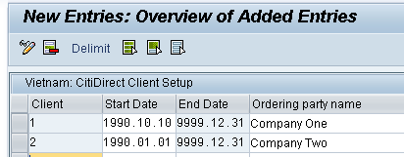

* + Feature -VNCB

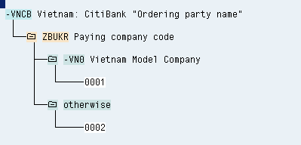

# General Ledger

## IMG Path & Table: Define Employee Grouping Account Determination

Path: Payroll 🡪 Payroll: Vietnam 🡪 Reporting for Posting Payroll Results to Accounting🡪 Activities in the HR system 🡪 Employee Grouping/Symbolic Accounts 🡪 Define Employee Grouping Account Determination

Feature: PPMOD

This step, you define the employee groupings for account determination. You do not have to specify employee groupings unless you want to post wage types to various accounts in Financial Accounting (FI) in line with employee attributes.

If you want to post to FI accounts with reference to a specific employee groupings, you must define an alphanumeric key of up to three characters for each of the required employee groupings. You then define the conditions for assigning employees to employee groupings that you have defined for posting to accounting . (You set conditions according to employee attributes, as defined by entries in the Workplace Basic Pay table (WPBP). Note that an employee can, at any one time, only be assigned to one employee grouping.

**Requirements**

In your enterprise, you have identified the groups of employees that are to be treated separately for posting to FI accounts.

**Standard Settings**

The standard system contains two employee groupings:

| Employee Grouping | Key |
| --- | --- |
| Hourly Paid EE | 1 |
| Salaried EE | 2 |

In the standard system, the feature PPMOD is based on the employee subgroup grouping for personnel calculation rules (ABART). (You use this feature to define conditions for assignment in the second activity in this step).

However, you can use other organizational attributes of the employee from table Work Center/Basic Pay (WPBP) as a field for the decision operation.

## IMG Path & Table: Define Symbolic Accounts

Path: Payroll 🡪 Payroll: Vietnam 🡪 Payroll 🡪 Reporting for Posting Payroll Results to Accounting🡪 Activities in the HR system 🡪 Employee Grouping/Symbolic Accounts 🡪 Define Symbolic Accounts

Table: V_T52EK

| SymAc | Description of the symbolic account | AATyp | EG |
| --- | --- | --- | --- |
| ;C00 | Wages | C | X |
| ;C01 | Overtime | C | X |
| ;C02 | Leave | C | X |
| ;C03 | Allowances | C | X |
| ;C04 | Bonus | C | X |
| ;C05 | Pension Ins. | C | X |
| ;C06 | ER Social Insurance | C | X |
| ;C07 | ER PHF | C | X |
| ;C08 | TAX ER Expense | C | X |
| ;F00 | Retro-calculations (/551, /552) | F |  |
| ;F01 | Bank Transfer (/557, /558, /559) | F |  |
| ;F02 | Claims & Arrears (/561, /563) | F |  |
| ;F03 | Unpaid Balances (/565 & /566) | F |  |
| ;F04 | Loans | F |  |
| ;F05 | Stock Purchase Plan | F |  |
| ;F06 | Social Insurance | F |  |
| ;F07 | PHF | F |  |
| ;F08 | TAX | F |  |

In this step, you create the symbolic accounts that you require for posting to Accounting.

A symbolic account has the following characteristics:

* A four-character alphanumeric code
* A descriptive text
* An account assignment type (AA type). This defines the type of posting (posting to expense account, posting to payables account, and so on) that applies to the wage types that are posted to the symbolic account.
* An employee grouping for account determination (EG) indicator

The following table shows what kind of account and what transaction is linked to an account determination type and what additional information (for example, for cost assignment) is also included in the posting transaction.

| AA type | Meaning | Transaction | Additional fields |
| --- | --- | --- | --- |
| CN | posting to expense account | HRC | cost assignment |
| E0 | posting to expense account without quantity | HRC | cost assignment without quantity |
| R | posting to expense account | HRF | expense not relevant to cost accounting |
| F | posting to expense account if accounting is installed in R/2 system | HRC |  |
| FL | posting to bal. sheet acct | HRF |  |
| FO | posting to bal.sheet acct for checking balance in retroactive accounting (recal. difference account) | HRF |  |
| FE | posting to bal. sheet acct (only in original periods if the wage types do not change retroactively) | HRF |  |
| Q | posting to bal.sheet acct | HRF | posting to bal.sht acct, evaluate C1/C0 |
| D | posting to bal. sheet acct with personnel number | HRF | personnel number |
| DF | posting to personal customer accounts | HRD | acc. Determination with personnel number |
| L | posting to fixed customer |  |  |
| K | posting to customer account (for specific loan) |  |  |
| KF | posting to pers vend accts |  |  |
| CN | posting to fixed vendor acc. |  |  |

Note the following with regard to account assignment types:

In the standard system, no quantities are transferred from wage types in the payroll result to the payroll documents and the resulting accounting documents, although information on quantities is available on the report log for report RPCIPE00 (or RPCIPX00). It is also possible to modify the system to access this information. The account assignment type CN is only useful if you have made this modification and if, in certain instances, you want to suppress the transfer of quantity information.

## IMG Path & Table: Define Symbolic Accounts

Path: Payroll 🡪 Payroll: Vietnam 🡪 Reporting for Posting Payroll Results to Accounting🡪 Activities in the HR system 🡪 Maintaining Wage Types 🡪 Define Posting Characteristics of Wage Types

Table: V_T52EZ

| CGrpg | Wage type | No | V | Prc | SymAc | AATyp | Text | IgnCA | Long text | End date |
| --- | --- | --- | --- | --- | --- | --- | --- | --- | --- | --- |
| VN | 1101 | 01 | + |  | ;C00 | C | Wages |  | Base Salary | 31/12/9999 |

In this step, you specify which wage types are to be posted, how often they are to be posted within the evaluation of one payroll result, and the symbolic account to be used for each posting.

You can also maintain the following posting characteristics:

**Plus/minus sign**

The system stores wage types with a plus (+) or minus (-) sign in the payroll result. How specific wage types are stored depends on how the system processes them during the payroll run. In the standard system, the sign is usually set correctly for secondary wage types. If you enter a plus sign (+) in the V column, positive amounts are posted as debits, and negative amounts are posted as credits. If you enter a minus sign (-) in the V column, positive amounts are posted as credits and negative amounts are posted as debits.

**Special processing of posting items**

This column is only significant for countries in which the function Month End Accruals is available. To post month end accruals instead of a regular posting, enter the letter A.

**Symbolic account**

**Account assignment type**

The account assignment type determines which account type is to be used for posting. It is defined by the symbolic account, and can only be displayed in this column.

**Indicator specifying whether the cost assignment for infotypes Recurring payments/deductions (0014), Additional payments (0015), and Employee remuneration information (2010) should be ignored (table C1).**

You only use this indicator if you want the system to ignore a different cost assignment when posting the wage type.

## IMG Path & Table: Assigning Accounts

Path: Payroll 🡪 Payroll: Vietnam 🡪 Reporting for Posting Payroll Results to Accounting🡪 Activities in the AC system 🡪 Assigning Accounts 🡪 Assign Balance Sheet Accounts

Table: T030

In this section, you assign accounts in Accounting to symbolic accounts in Human Resources . According to this assignment, during posting to Accounting, the accounts in Financial Accounting are assigned to line items for which symbolic accounting has been performed.

With the exception of the technical accounts, the activities for the various account types contain an identical step, that is, you must define the rules for the corresponding posting transaction. Note the following information for carrying out this step:

* The Debit/Credit indicator must only be set if you want to post debits and credits to different accounts. It is not advisable to set this indicator, since in posting to Accounting, only summarized documents are posted.
* If you set the EE group indicator, a further column EE group appears in account assignment. You must only set this indicator if you want to post to any symbolic account for a specific employee grouping. You make the relevant settings for posting to symbolic accounts in the step Define Symbolic Accounts.

# Schema and Rule Information

## Standard SAP Schema

The standard SAP Schema for Vietnam is -VN0.

## Standard ADP Schema

The standard ADP Schema for Vietnam is ;VN0.

## Standard ADP Rules Naming Convention - Vietnam

The standard ADP Rules Naming Convention for Vietnam Specific Rules is as follows:

### Country Specific Rules

1st Character: ‘=’

2nd Character: V = country Identifier

3rd & 4th Characters: alphanumeric counter starting with the letter 01 and going through to the letter ZZ.

### Client Specific Rules

1st Character: ;

2nd Character: V = country Identifier

3rd & 4th Characters: alphanumeric counter starting with the letter 01 and going through to the letter ZZ.

## Schema: SI calculation amendment on employees less than 14 working days

Employees in Vietnam should pay contributions towards Social Insurances.

However there is an exception to this rule as described in article 85.3 of the Social Insurance Law No: 58/2014/QH13.

According to this stipulation:

*Employees who neither work nor receive salary for 14 working days or more in a month are not required to pay social insurance premiums in that month. This period shall not be counted for enjoyment of social insurance regimes, except cases of maternity leave*

The current solution however applies this rule based on a Work percentage principle.

SI is calculated only when an employee is active on the 15th and worked more than 50% of working days.

The work percentage is calculated as ((number of days worked – unpaid days) / number of days worked).

This may result in an employee being only absent for 13 days but the work-percentage is less than 50% so no SI is calculated.

* Payroll function _VNSI was updated to allow for the checking of unpaid absence days based on parameter 3
  + Options for parameter 3:
    - P – work percentage (If less than 50% no SI calculation)
    - D – Unpaid absence days count (14 days or more , no SI calculation)
    - A – SI will be calculated regardless (no checks for P or D done)
  + Log printing was also updated to show more information in the payroll log.
* Schema -VN7 was updated to update parameter 3

The default solution will still use the work percentage check.

The standard schema -VN7 is now configured as depicted in the image below:

The value ‘P’ replaces the previous value of ‘15’.

The P now indicates the ‘Percentage’ option.



If the client wants to change this work-percentage check to a check based on the 14-day rule, this schema (or customer version) should look as follows:



Alternatively if neither of these checks are valid the option ‘A’ can be used.

**NB: If schema -VN7 was replaced by a customer version it HAS TO be updated as the previous value ‘15’ will not work and it will result in a schema generation error.**

In such a scenario, replace the 15 in parameter 3 by either ‘P’ or ‘D’ and if you used a blank before for parameter 3, replace it with an ‘A’.

In function _VNSI each function, it calculates the active days of the employee to determine Unpaid leave for calculate SI contribution.



Payroll log will show more detail information:

For option ‘P’, work-percentage is checked:



For option ‘D’ number of absence days are checked:



# Standard Feature

## Feature -VNGL

The PIT finalisation calculation needs a go-live date when the go-lice date is in the middle of the tax year.

## Feature –VNFP

Available to activate the tax finalization calculation for employees who were hired mid year

## Feature –VNSC

Default Payroll schema on selection screen